AQA NEA Project

Book Platform with Logistical Route Finder

Full Name: Konrad Wila  
Candidate Number: 6357  
Centre Name: Maidstone Grammar School  
Centre Number: 61715  
Project Title: Book Platform with Logistical Route Finder  
Year: 2020

Contents

Analysis 1

Overview 1

Objectives 2

Problem Background 3

Current System 3

Analysis Techniques 3

Proposed Solution 3

Proposed Users 3

Investigation 4

Analysis Log 6

Documented Design 7

Introduction/Overview 7

System Design 8

Data Structures 10

Interface 26

Technical Solution 31

Testing 40

Evaluation 57

Bibliography 111

# Analysis

## Overview

The project is dedicated for people who would like to buy a book or add a book to the program. Users which intend to buy a book can search for it, and be offered a price for the book that they are interested in. The customer is then prompted with two delivery options: collection at the shop the item that it is already located in, or the item can be transported to their preferred other branch of the shop. If transport is required, the items will be placed into a list and then calculated into an efficient collection and delivery route for a single vehicle during one day.

## Objectives

1. **User Selection and Purchasing–** The program will allow new or existing users of the program’s database to view and select items for delivery.
   1. **Login –** User details are looked up in the database and allowed to access the store.
      1. The user enters their details in the program and submits them.
      2. The details are used to check if the user can access the system and their role is found.
      3. Depending on the user’s role a one of three different screens will appear:
         1. Customer
         2. Driver
         3. Manager
   2. **Item Selection –** User can select the item that they require.
      1. **Items will be displayed –** The items for the user to choose will be displayed in a window for the user to select the product that they would require to obtain.
      2. **Selection of wanted product –** There will be an option for the user to select the item as wanted.
      3. **Updating the customers’ orders –** The item will be marked as needing to be delivered.
2. **Delivery Calculation** – The program will calculate the driver’s route to deliver the items to their destinations.
   1. **Collection of Items–** Items which need to be collected are input into the program.
   2. **Delivery path finding –** The item has information for the driver to know where the item should be delivered. Dijkstra’s shortest path algorithm is used to calculate the shortest distance required to deliver the items. Distance will be used as a measure of efficiency since this should reduce petrol costs and vehicle usage than a longer distance route.
   3. **Path display –** When the route is calculated it will be displayed in the program for the driver to view.
3. **Shop manager’s overview panel** – Allows the owner to manage their shop. Information such as book prices; popular categories will be displayed.
   1. **Addition of items –** When new books arrive at the store they can be added to the system and placed on the bookshelf.
   2. **Removal of Items –** The manager can click on the book to be removed and delete that item from the database.

## Problem Background

The customer navigates to a page where they could search and select the items that they want to order. The items that the customer has selected would be marked. A transport route will also be created to transfer the books between these “collection points” and delivered to each location.

## Current System

In the current system there is a lack of cohesion between stores. Items are brought into each store where they are priced and labeled with a display date. The display date indicates when the item has been on display at the store for too long without selling and needs to be rotated to another store. This occurs to increase the chances of the item being sold and giving customers a regular new selection of items. After five rotations the item is discarded and sold to an online company by the kilogram for very little money. The chances of books being sold would increase if customers could browse all the books available across every store at once.

## Analysis Techniques

I can interview a book shop manager to gather information on the processes that occur at the shop as well as my own experience during my time volunteering at a store. Customers entering the store could also be surveyed about their opinions about the system and interviewed.

## Proposed Solution

Allowing customers to browse the stock of multiple stores will reduce the need for stock to be rotated between stores. Instead only the books that are required will be transported. This system will also increase customer satisfaction as it will allow for items to be searched for allowing a specific book to be selected that could also mean that customers would be willing to spend more money on the item than usual as it is something, they already want rather than stumbling across it. The

### Proposed Users

The system will be used by several users who will have different access rights:

* **Customers –** Allowed to browse through the available items and select the items they require
  + Read access to the inventory storing details on the items like price, title, author
  + Access to their details stored in the database like preferred pickup store so that the store can be selected by default as the place that items will be delivered to
* **Store Managers –** Made aware of the items that are incoming or outgoing and directed to the action to take. Also, able to add and remove stock from the system.
  + Read and write access to the inventory in the store that they are managing so that items that are donated to the store can be added to the database and added to the items that are available in the store.
* **Delivery workers –** Having a route planned for pickup and delivery of items.
  + Read and write access to the inventory across the stores that they are delivering to. This allows for items to be marked as belonging to another store after being delivered
  + Delivery routes will have to be calculated for the driver to take.
  + Items will have to be marked as being delivered by the driver, allowing for the item to be collected

### Investigation

#### Similar Systems

There is a wide variety of ordering systems that have been created from table service in a restaurant to the delivery of takeaways to customers to more bespoke systems. One of the best examples of an existing system would be Amazon. The company allows customers to browse search and select the items that they would like. There are also separate systems for delivery, where drivers download an app on their phone or use a PDA to confirm deliveries and view their route. I will evaluate Amazon’s systems as it shares the most traits with the system that I 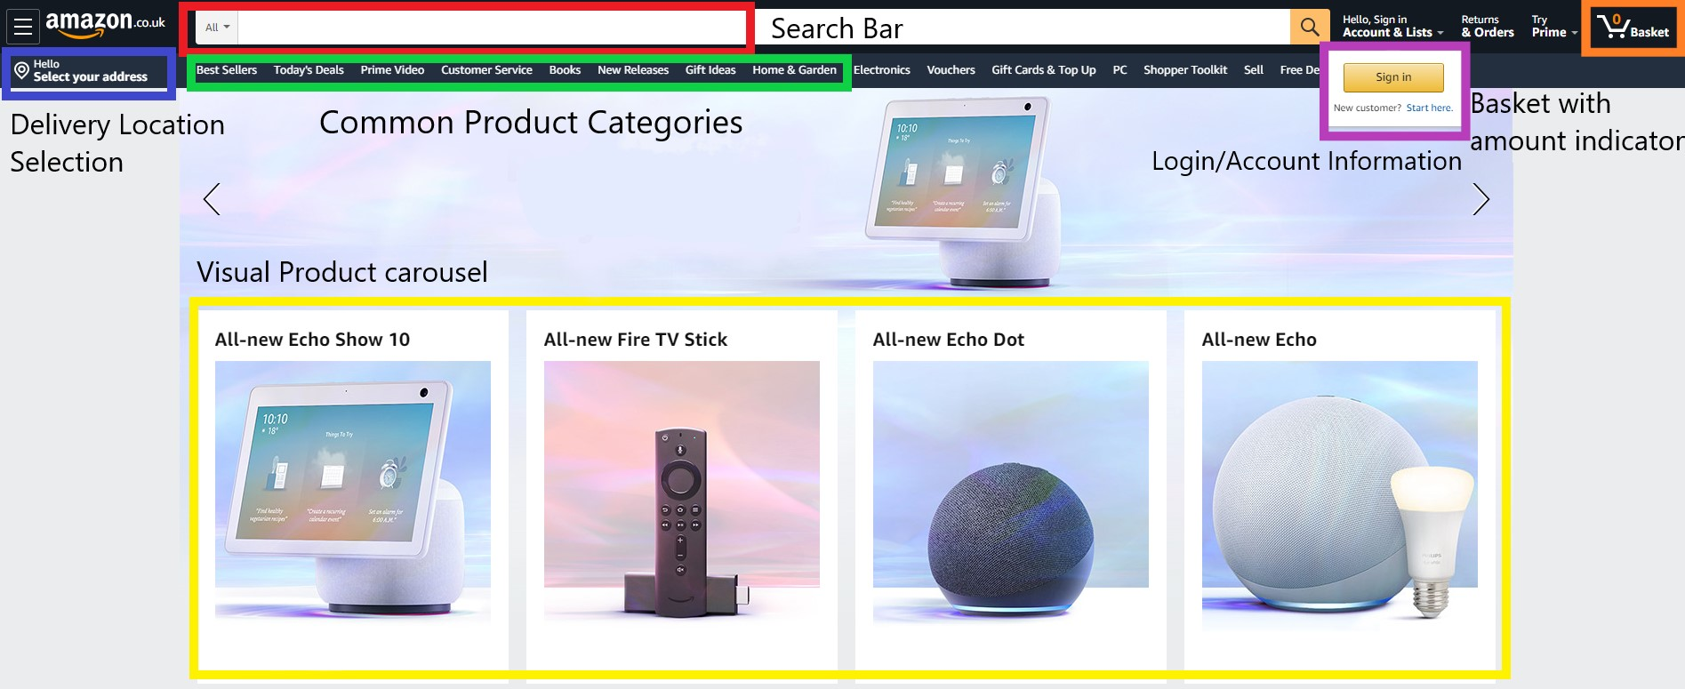am trying to achieve.

Figure 1 Amazon's customer homepage layout on a desktop browser

Amazon has a clear and simple to grasp webpage layout. The top toolbar has a search input allowing customers to find specific items (labelled red) combined with an area in the upper right corner dedicated to managing your account and orders (labeled orange). Selecting your delivery location (labelled blue) has been separated from the orange management corner since in Amazon’s case delivery location will impact shipping times and availability of products. This nudges the customer to select delivery location early on. Already from the homepage customers can already start to direct themselves to the product that they would like to purchase using a variety of tools as selecting categories (green) using the search bar (red) or viewing the most popular products with highly visual representations (in yellow)

**Amazon’s Delivery Driver Application**

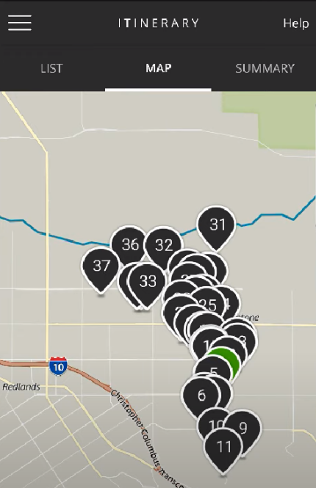

Drivers can select the route that they would like to complete and receive a visual overview of the stops and route they are completing

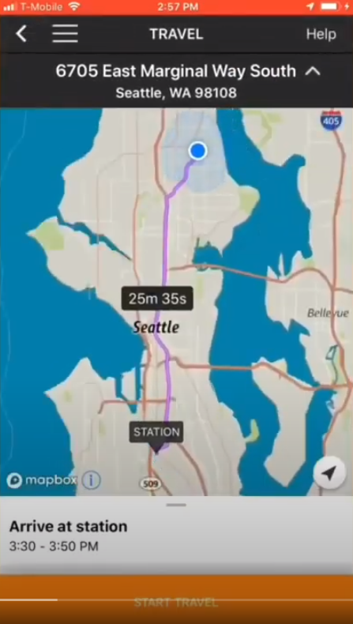

The app provides turn by turn instructions to each delivery location, reducing time needed for setting up navigation.

## Analysis Log

|  |  |  |
| --- | --- | --- |
| **Date** | **Activity** | **Findings** |
| 21/7/2020 | Creating login portals for the different users of the system | Splitting the window in half allows the customer to register or login and allows a window for each user type. |
| 21/8/2020 | Creating an ISBN validity checking algorithm | Completed, ISBN numbers are 10 and 13 digits long with a check digit at the end. |
| 21/9/2020 | Creating a logical delivery path appropriate for the delivery route type. | Books will have to collected in one direction then any locations which still need a delivery will be visited and a path will have to be calculated again. |
| 06/11/2020 | Allowing items stored in the database to be seen in the manager’s view | To connect to a database ADO.Net data access technology must be used which includes an OleDbConnection Class |
| 20/12/2020 | Planning the user item selection screen | Display and selection of items |

# Documented Design

## Introduction/Overview

The core parts of the system will be the delivery algorithm which will determine how the books are transferred between the delivery points. This will need to be supported by a customer selection system to provide data on what books are to be transferred by the system.

All users will have to have an account on the system which will allow each user to access their specific portal screen. Customers will be able to select the items that they require by searching and selecting from the items that are available. A delivery location will be entered, and the item will be marked as requiring delivery which will allow the item to be transported.

The delivery driver for each day will request the system to generate a delivery route for each day. The system will calculate the path and display the result to the driver. The route is provided as a link to a mapping service (e.g. google maps).

The manager overview will allow items to be added and removed from the system as customers collect or add items into the system. This will allow the stock inside of the database to remain representative of actual stock levels.

The system will require a DB system to centrally store the results and data in the system for other users to access. The data stored will include details on user, stock, and transport information. This will allow the same data to be accessed between multiple different users.

## System Design

#### Database entity-relationship diagram

Figure 2 Initial draft of the database diagram

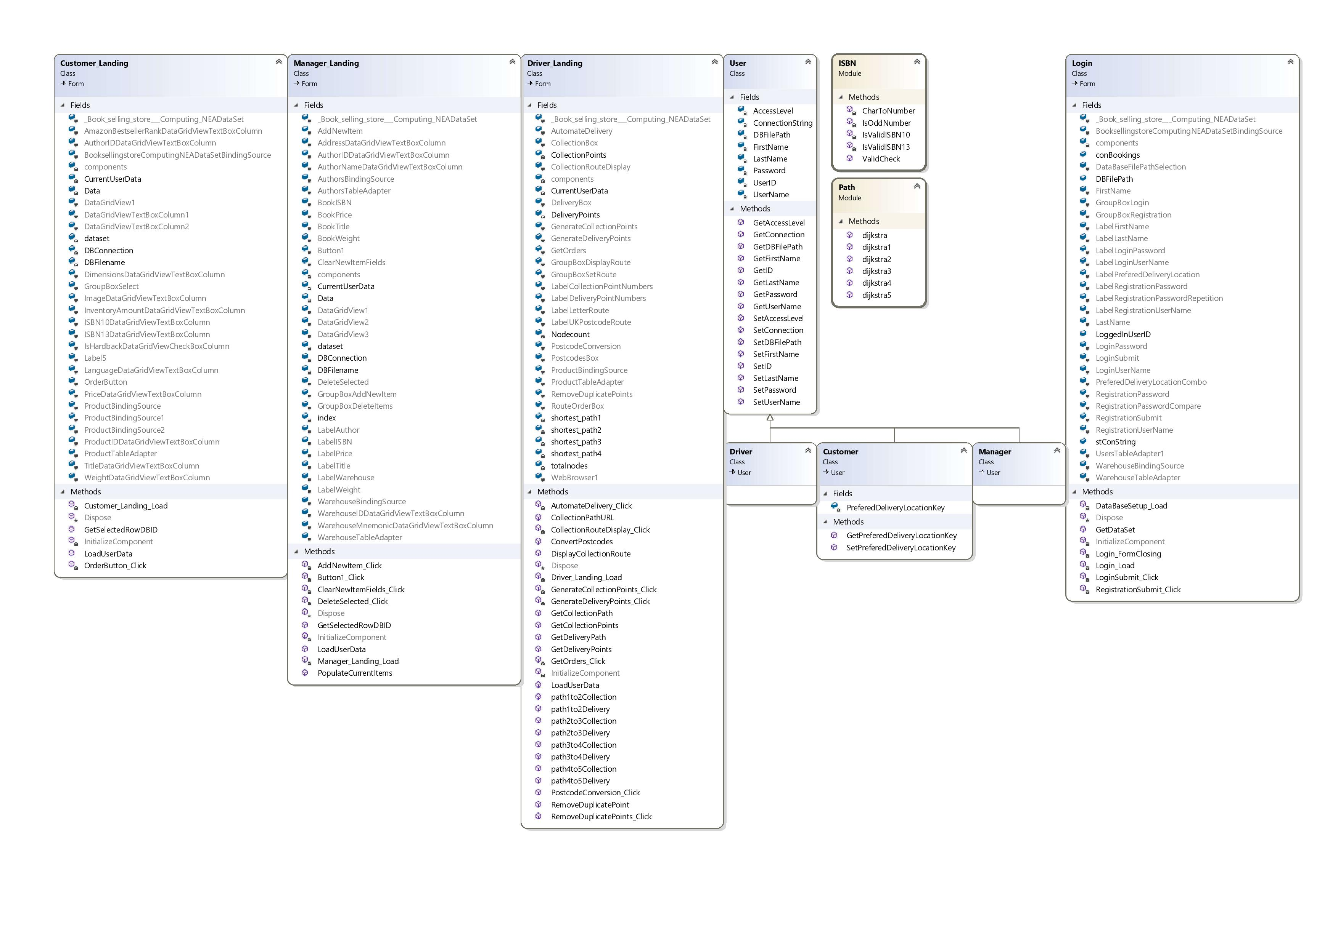

Figure Class diagram

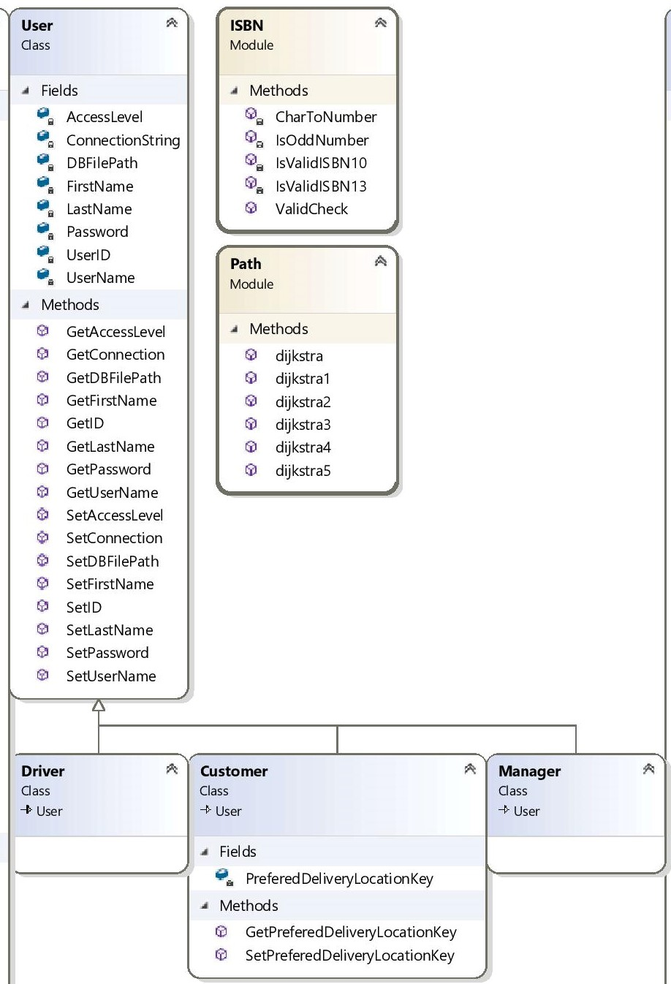

Figure 4 Inheritance Diagram

## Delivery Route Algorithm Explanation

Figure 5 Simplified example scenario of where the program could be applied

The image above shows the delivery locations that would be part of the program and deliveries would be made between these points, shown as blue pins. The books requiring delivery and their desired location are illustrated in orange. A delivery algorithm is needed that will direct the driver to take an efficient route and complete the required deliveries.

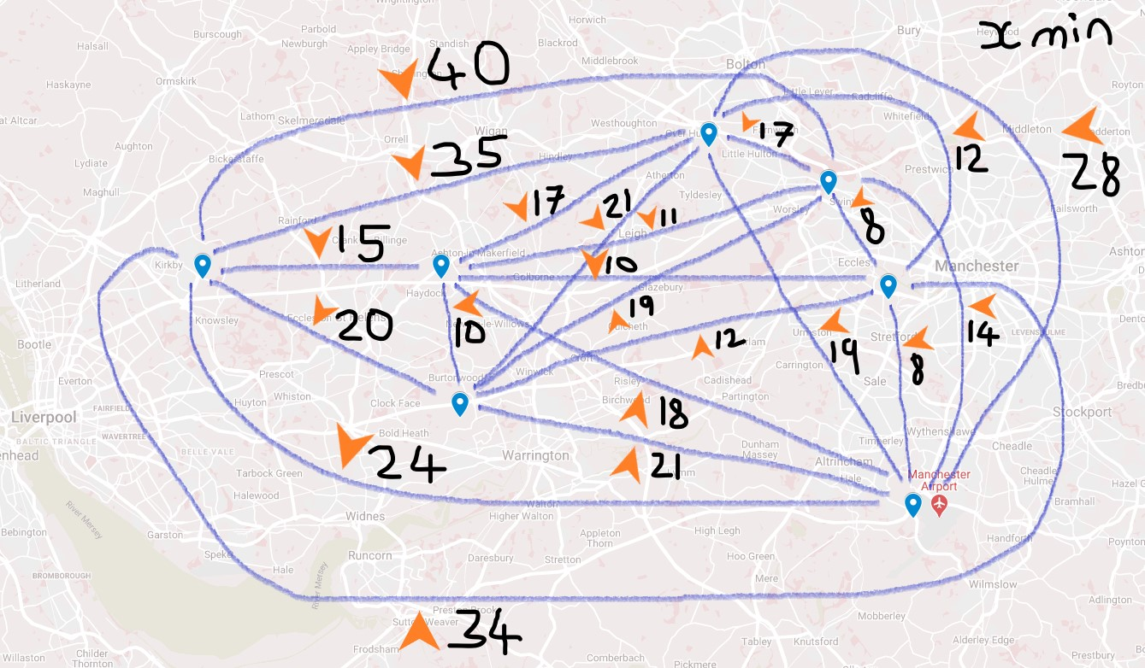

Figure 6 Weighted graph showing times between locations in minutes in the example scenario

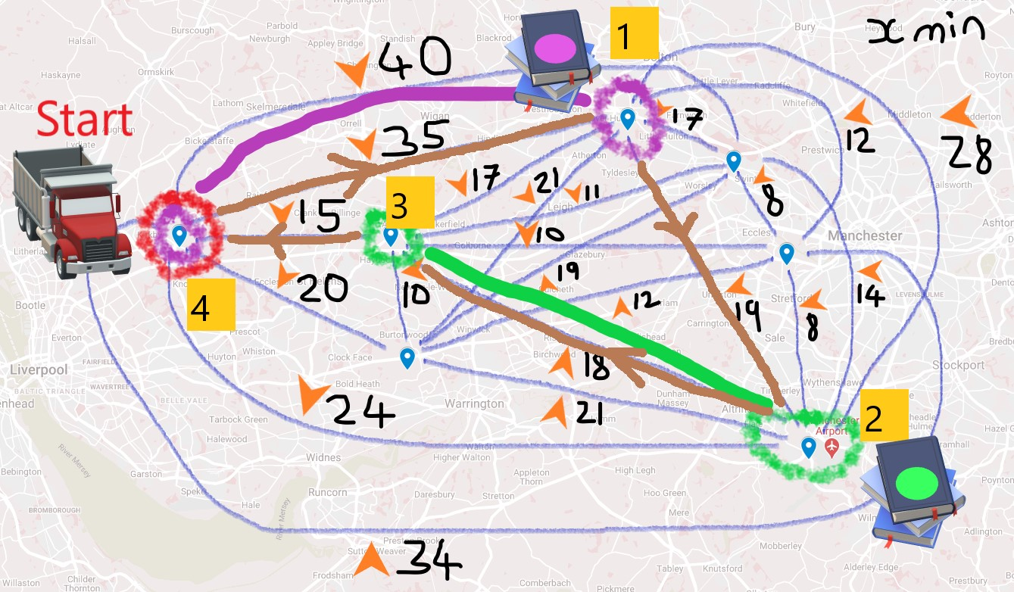The delivery algorithm will work in stages to complete a route for that day. An example of a route the algorithm should produce is shown above in brown colour (Figure 7 Example of a calculated route between all the points to be visited). The vehicle starts at the point circled in red and drives to each of the locations where books are to be collected. When all the books have been collected the algorithm should decide if any of the books could have already been delivered using the planned path. The remaining books for delivery are then used to plan another route using Dijkstra’s algorithm, after which all books are delivered. Below is a flow chart of the process that is used.

Figure 7 Example of a calculated route between all the points to be visited

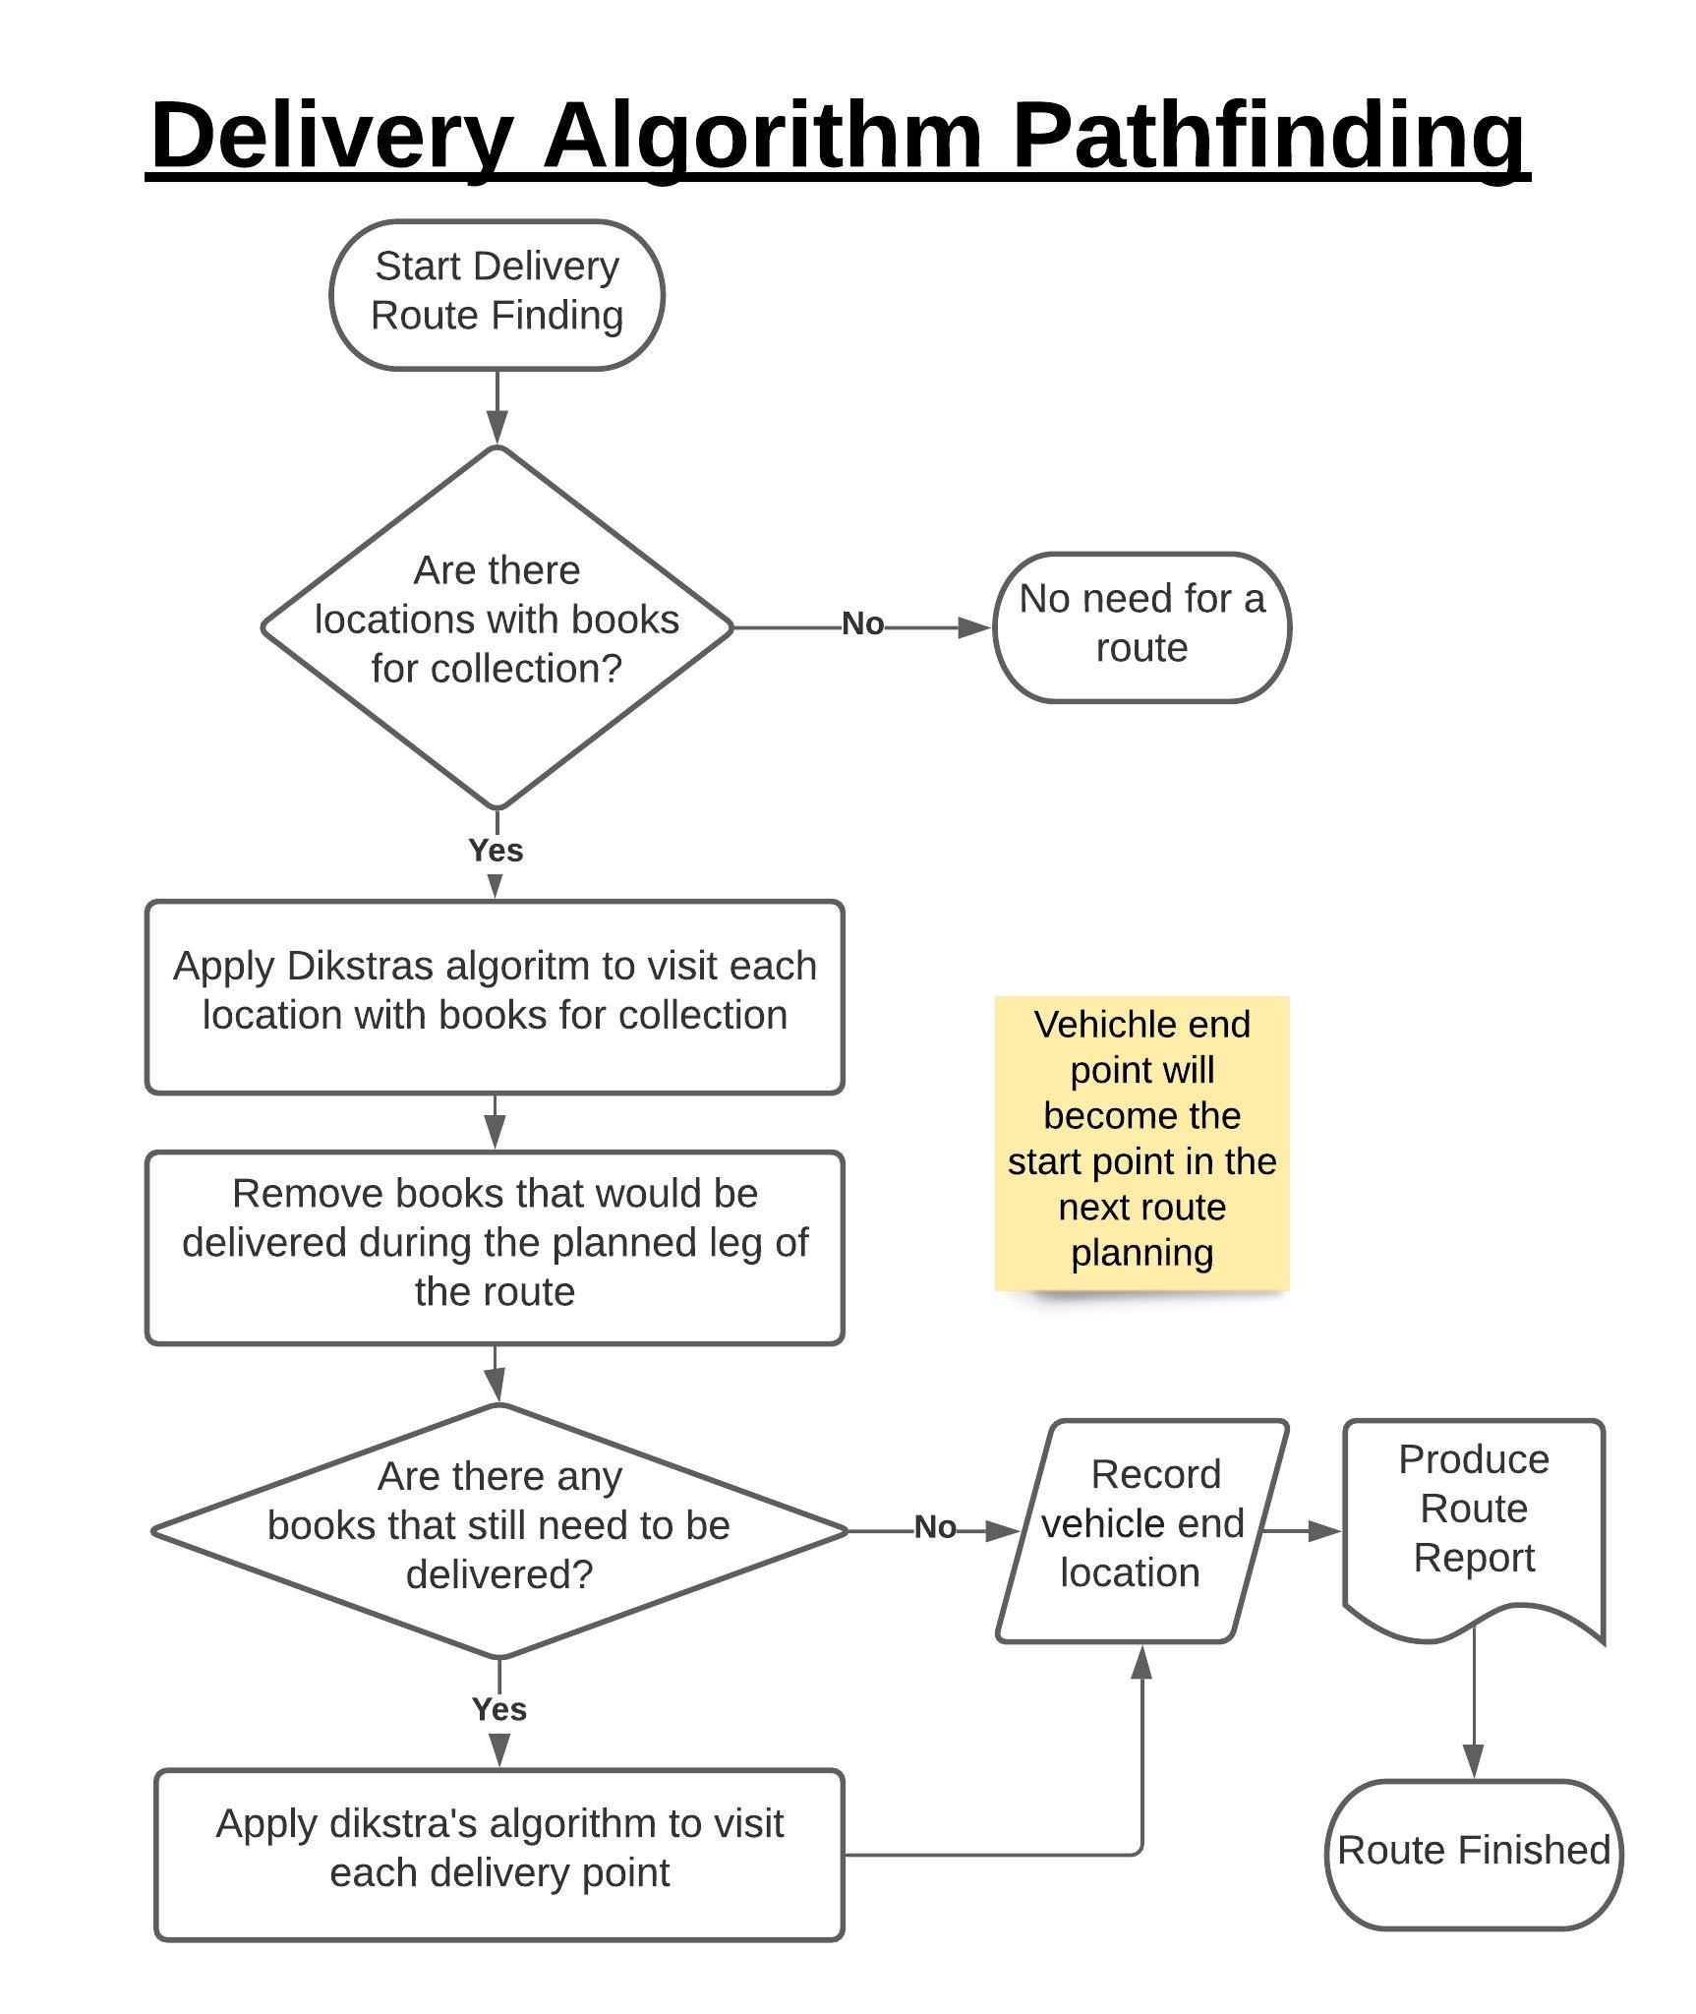

## Data Structures

The system will need to store user details as well as the inventory of books that are held. A database will be used which will allow the data items store in the table to be stored in a way where they can be easily located to allow for quick retrieval.

A graph distance matrix will be used to store the distances between all the points that the vehicle will travel to. This will allow for pathfinding to be more efficient when planning routes.

**Data Base Normalization**

The database will have to be normalized this allows data to be stored accurately, reducing redundancy and incorrect dependencies. This also allows for greater flexibility in the database allowing for the database to be extended or altered more easily in the future. Therefore, database normalization will be an important step avoiding anomalies in the future reducing storage space and improve performance.

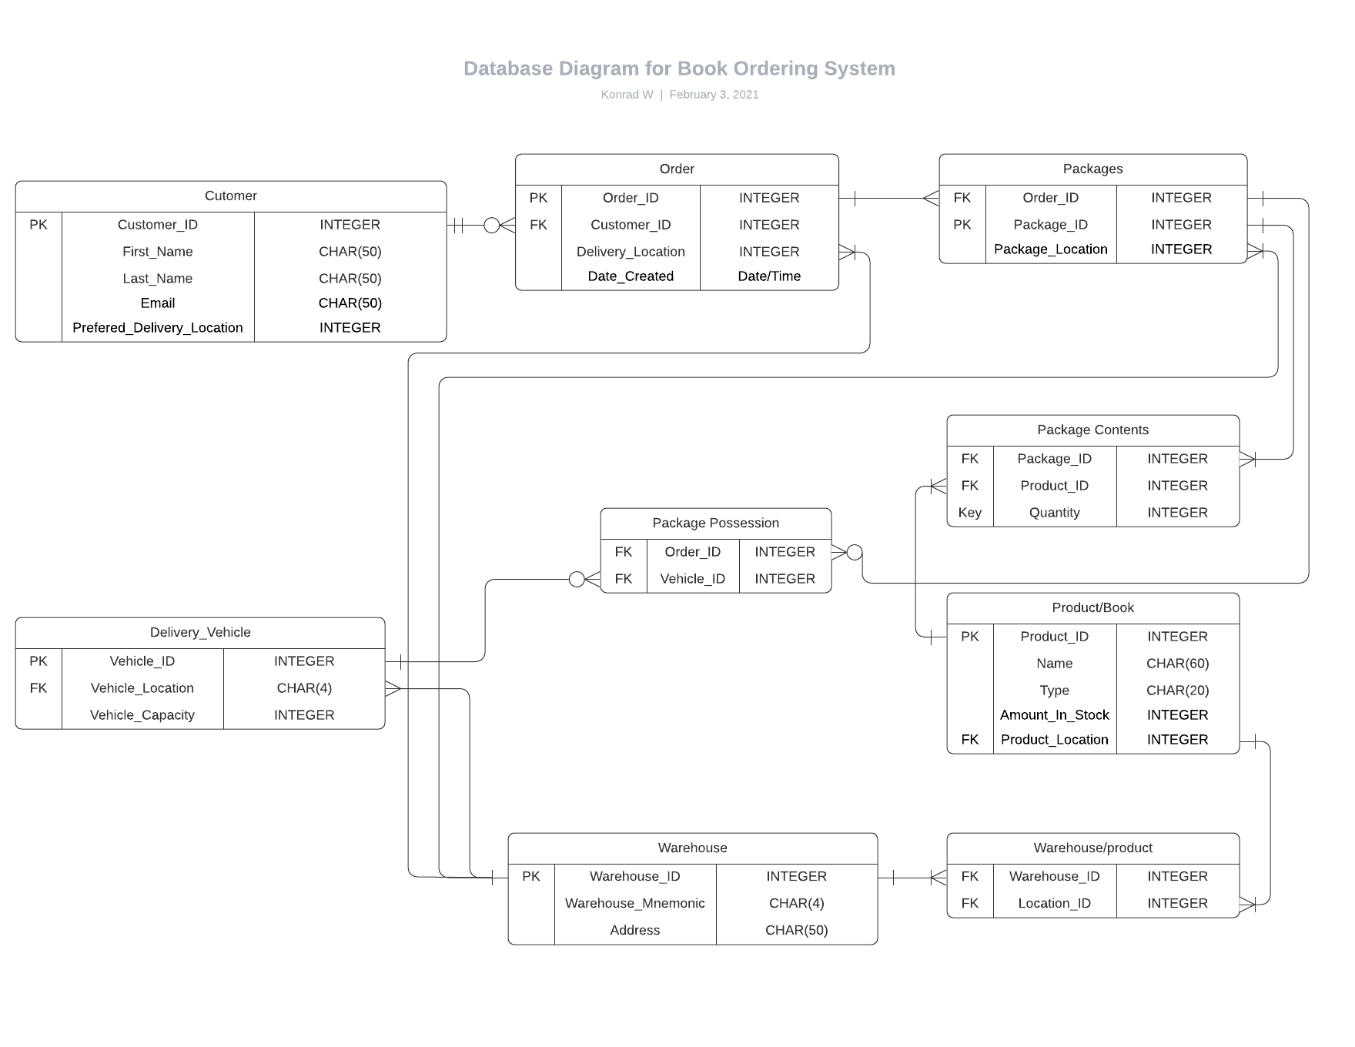An initial sketch of the database is shown below:

The initial database design was:

Customer (User_ID, FirstName, LastName, UserName, PreferedDeliveryLocation, Password, Accesslevel, Order_ID, Time of ordering, Book, Quantity)

Product (Product_ID, Title, Image, Price, Language, Weight, Dimensions, ISBN-10, ISBN-13, Is Hardback, Bestseller Rank, Inventory amount, Author Name)

Driver (Driver_ID, Vehicle Location, Vehicle Capacity, Packages)

When these three tables where normalized the results were:

Users (User_ID, FirstName, UserName, PreferedDeliverylocartionID, Password, AccessLevel)

Order (Order_ID, CustomerID, Time Ordered, Book_ID, Quantity)

Package (Order_ID, Package_ID, Package_Location)

Warehouse (Warehouse_ID, Warehouse_Mnemonic, Address)

Package_Possession(Package_ID, Vehichle_ID)

Delivery_Vehicle (Vehicle_ID, Vehichle_Location, Vehichle_Capacity, Driver_ID)

Product (Product_ID, Title, Image, Price, Language, Weight, Dimensions, ISBN-10, ISBN-13, Is Hardback, Bestseller Rank, Inventory Amount, Author ID)

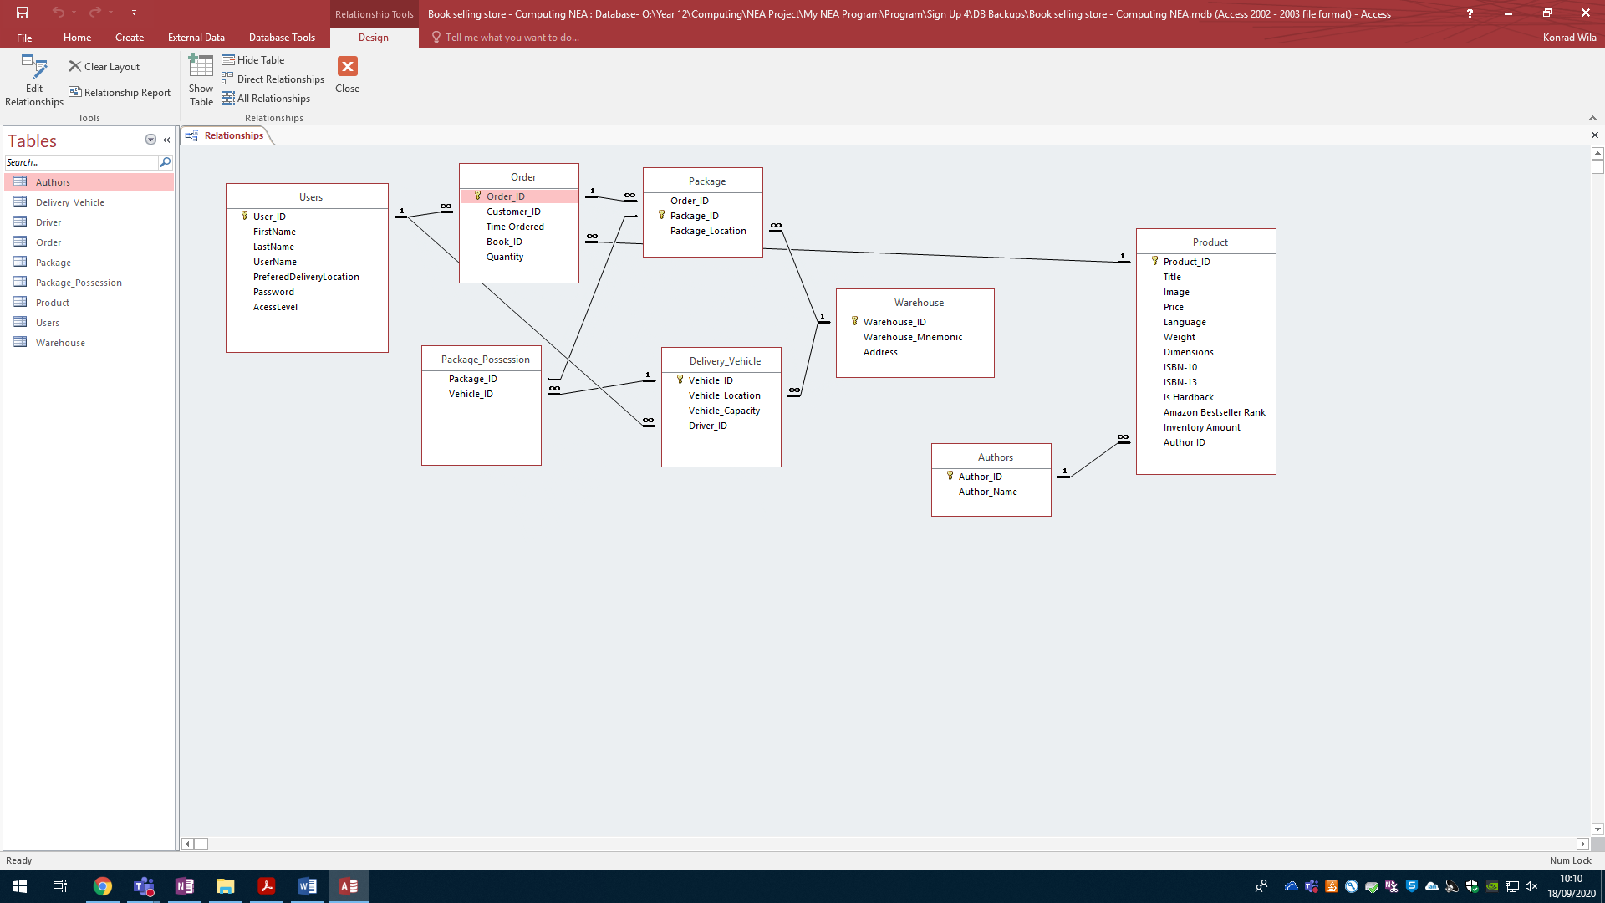

Figure 8 Database first draft

Figure 9 Database Second Draft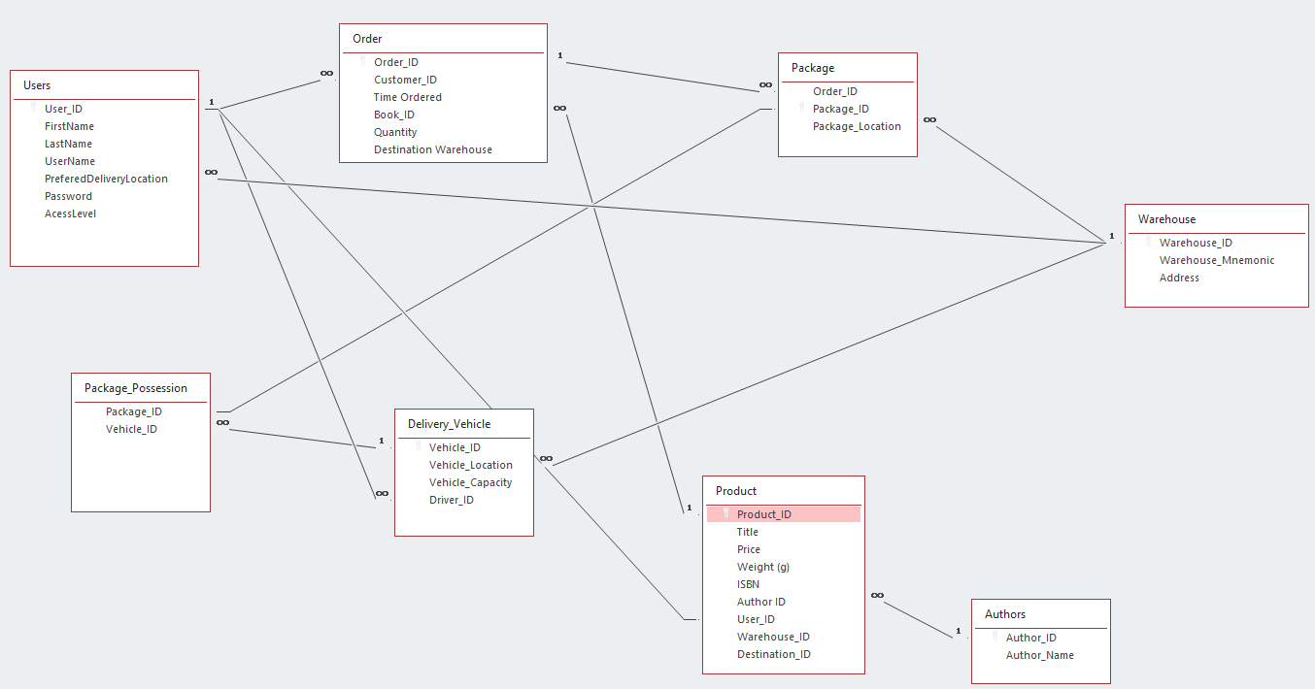

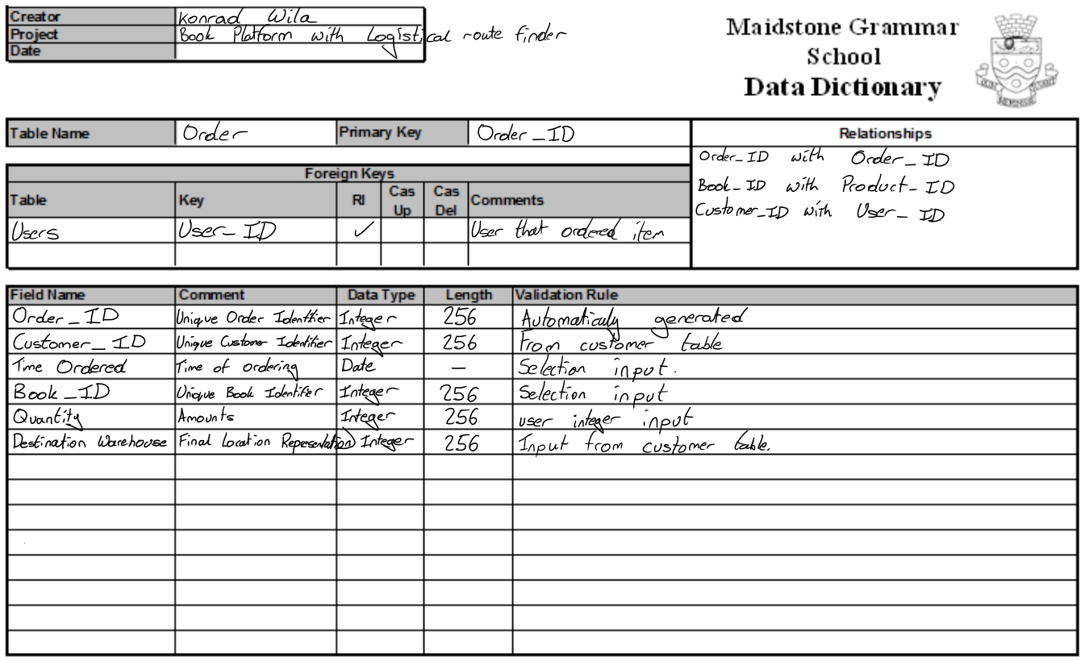

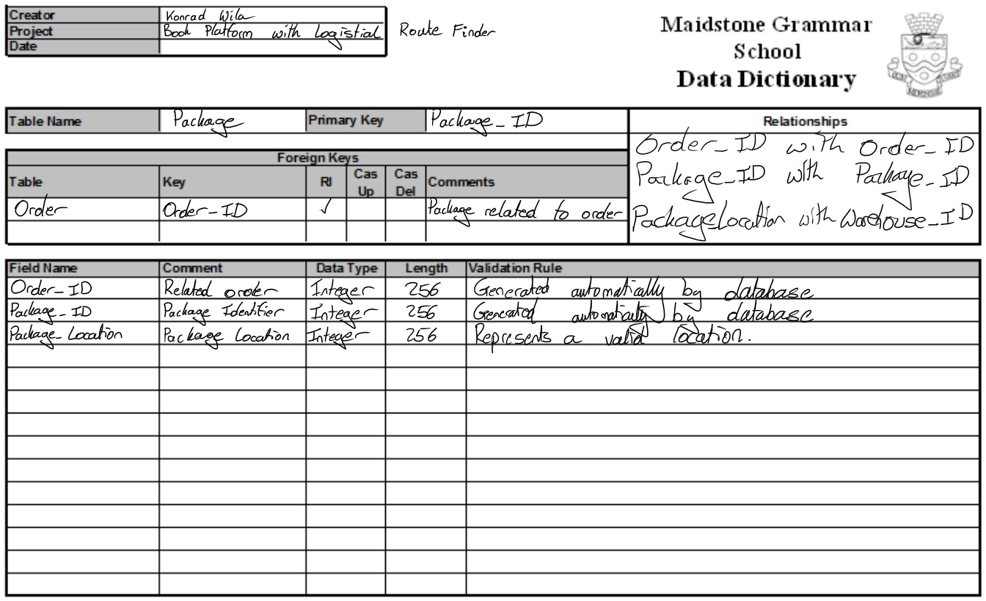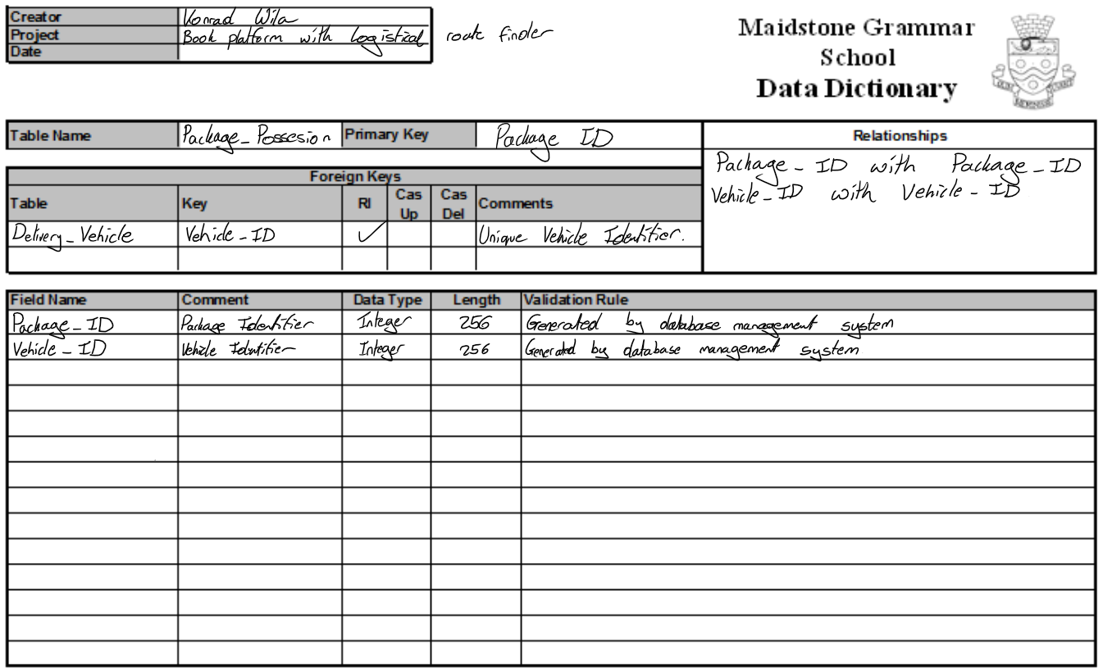

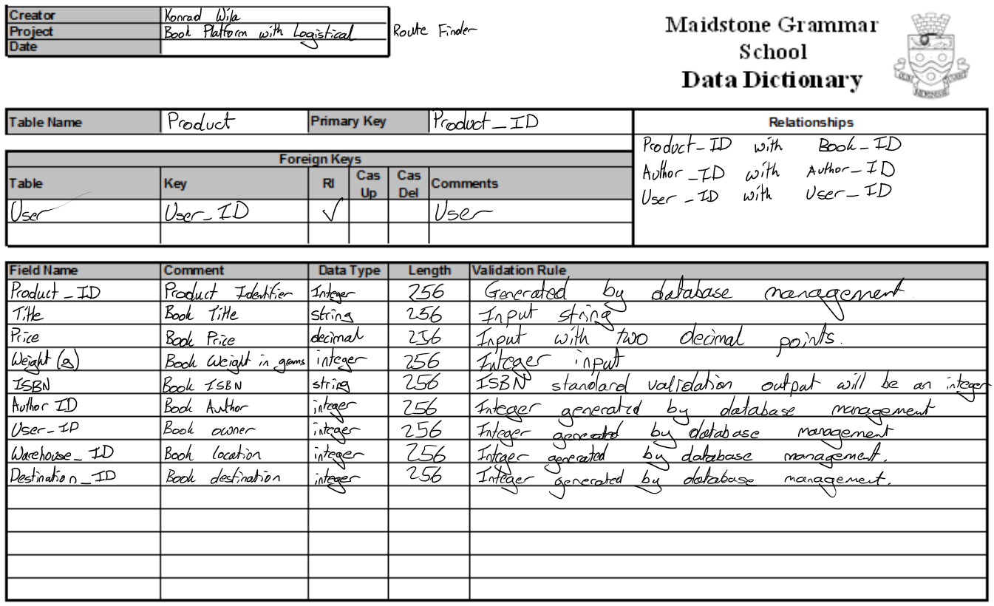

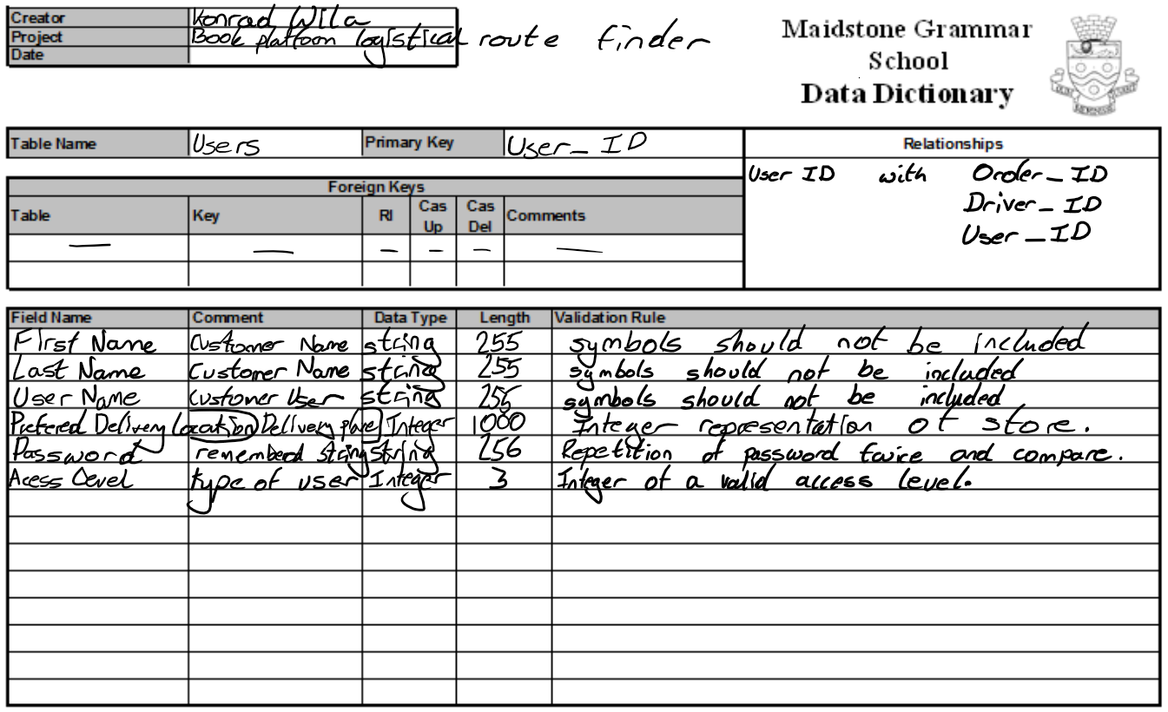

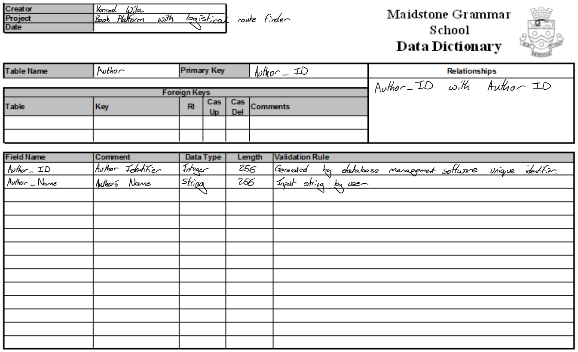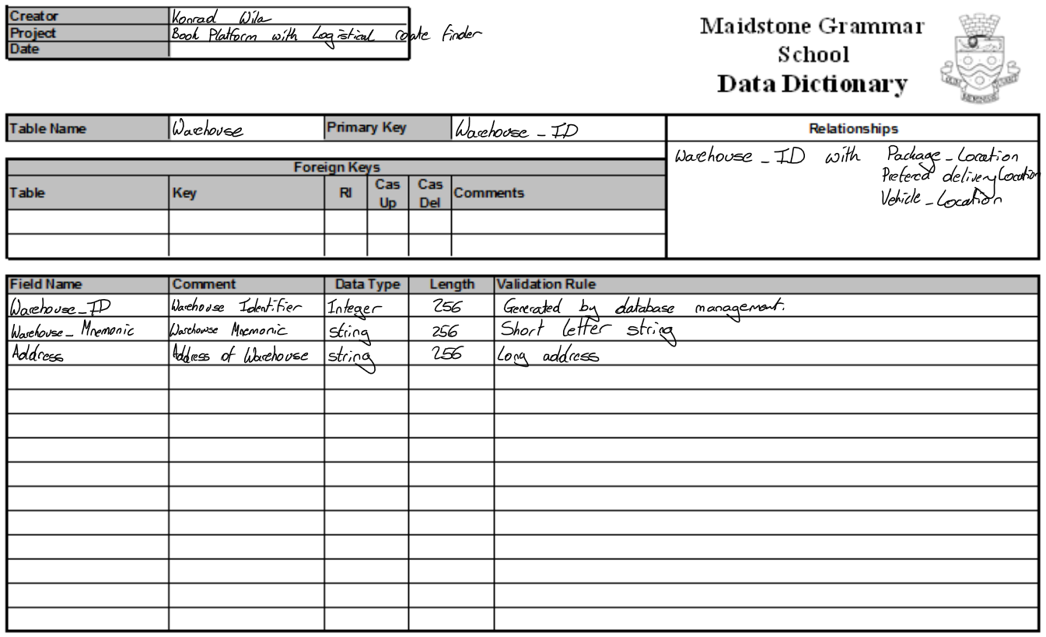

Arrays will be used to store the books that need to be transported for each item’s storage location. Each book that requires to be collected will be added to the array. When all the books have been collected any books that can be delivered during the collection route will be removed and marked as delivered. This means that when the delivery driver completes all their collections by going through the array. The books that could be delivered at the same time as collecting book can be removed from the delivery array. This means that the books that are left over are used to create another final delivery path using the items that remain in the array.

# Program

There will be one window that each user will see when they open the program this will then require one out of three other screens to be displayed. Customer, manager, and driver each of these will need a preliminary design.

#### Human Computer Interaction Windows Draft Designs

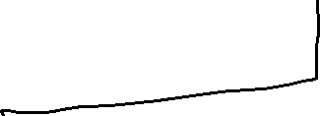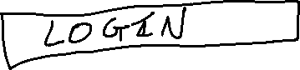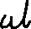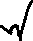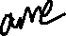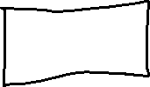

Figure 10 Registration screen mockup draft

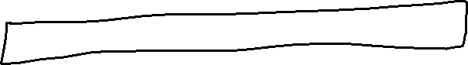

Figure 11 Customer Screen Mockup draft

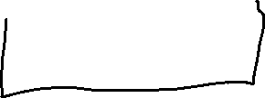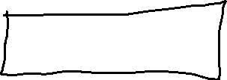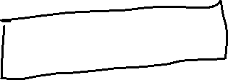

Figure 12 Manager Screen Mockup Draft

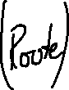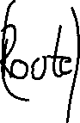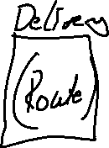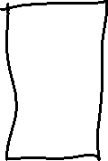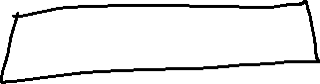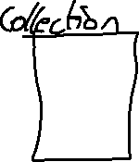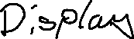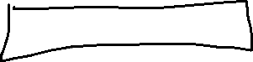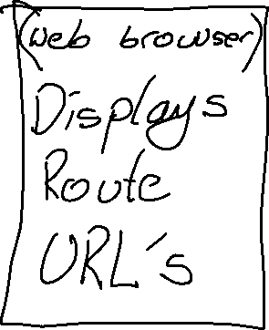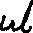

Figure 13 Delivery Route Screen Mockup Draft

## Landing Page

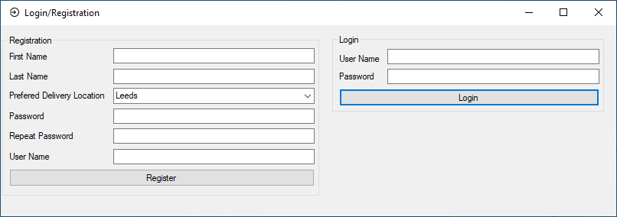

Figure Login/Registration screen

Every user will have to register and login to use the program. Having the screen split in half creates a logical order of actions to take, if registering use the left column or the right for login. Then working your way from the top to the bottom to complete the action gives a simple intuitive interface.

### Implementation

Since the program will be divided into three separate interactive screens manager, customer, driver unified by a ‘login’ screen. The order of development is:

1. Login
2. Manager – Allowing items to be added to database
3. Customer – Ordering items
4. Driver – route planning of items to be delivered

The database will have to be loaded and accessible to the program This will allow the login details that are entered to be compared with the stored details.

 ''Konrad Wila

''Window icon from https://icons8.com/

''Delete Import statements that turn out unnecessary

Imports System.Data.OleDb

Public Class Login

Dim stConString As String

'Dim loggedinPassword As String

'Dim loggedinAccessLevel As Integer

Private Sub RegistrationSubmit_Click(sender As Object, e As EventArgs) Handles RegistrationSubmit.Click ''Registration Page

''Compare the two passwords to see if they are the same

If RegistrationPassword.Text = RegistrationPasswordCompare.Text Then

''Passwords match proceed adding user

''Check all fields have been completed

If (String.IsNullOrWhiteSpace(FirstName.Text) = True) Or (String.IsNullOrWhiteSpace(LastName.Text) = True) Or (String.IsNullOrWhiteSpace(RegistrationPassword.Text) = True) Or (String.IsNullOrWhiteSpace(RegistrationPasswordCompare.Text) = True) Or (String.IsNullOrWhiteSpace(RegistrationUserName.Text) = True) Or (String.IsNullOrWhiteSpace(PreferedDeliveryLocationCombo.Text) = True) Then

MsgBox("Blank or null fields are not valid")

Else

''TODO: Continue adding user, passwords match and no blank fields

Try ''Add the user to DB

MsgBox("Success, added to database!")

Catch ex As Exception

MsgBox("Error occurred while saving your details")

End Try

End If

Else

MsgBox("The passwords entered do not match, please enter matching passwords and try again")

End If

End Sub

This code is executed when the registration form is submitted. The program makes sure that all the fields are filled out and then will add the user to the database. Otherwise an error message will be displayed explain that there are bank fields or that the passwords do not match.

Private Sub LoginSubmit_Click(sender As Object, e As EventArgs) Handles LoginSubmit.Click ''Login page

If LoginUserName.Text = "" Then

MsgBox("Please enter a Username")

Else

If LoginPassword.Text = "" Then

MsgBox("Please enter a Password")

Else

''No blank login details provided, now check against the DB

Dim stSQL As String = "SELECT * from Users WHERE Username = '" & LoginUserName.Text & "' AND Password = '" & LoginPassword.Text & "'"

Dim UserLogonRecord As DataSet = GetDataSet(stSQL)

Dim t1 As DataTable = UserLogonRecord.Tables("Users")

Dim row As DataRow

For Each row In t1.Rows

Dim Arrange As String = Arrange & row(0) & " " & row(1) & " " & row(2) & " " & row(3) & " " & row(4) & " " & row(5) & " " & row(6) & vbNewLine

Next

''User data is stored in the following format

''Do t1.row(number) to retrieve the stored data

''Row 0 = UserID

''Row 1 = FirstName

''Row 2 = LastName

''Row 3 = UserName

''Row 4 = PreferedDeliveryLocation

''Row 5 = Password

''Row 6 = AccessLevel

Dim LoggedInData As New User

LoggedInData.SetID(CInt(row(0)))

LoggedInData.SetFirstName(CStr(row(1)))

LoggedInData.SetLastName(CStr(row(2)))

LoggedInData.SetUserName(CStr(row(3)))

LoggedInData.SetPassword(CStr(row(5)))

LoggedInData.SetAccessLevel(CInt(row(6)))

If LoggedInData.GetPassword() = LoginPassword.Text Then

''Sort window action according to access levels

Select Case LoggedInData.GetAccessLevel()

Case = 1 ''Customer level screening

Dim LoggedInFull As New Customer

LoggedInFull.SetID(LoggedInData.GetID())

LoggedInFull.SetFirstName(LoggedInData.GetFirstName())

LoggedInFull.SetLastName(LoggedInData.GetLastName())

LoggedInFull.SetUserName(LoggedInData.GetUserName())

LoggedInFull.SetPassword(LoggedInData.GetPassword())

LoggedInFull.SetAccessLevel(LoggedInData.GetAccessLevel())

''Unique to customer properties added

LoggedInFull.SetPreferedDeliveryLocationKey(CInt(row(4)))

Me.Hide()

Customer_Landing.LoadUserData(LoggedInFull) ''Populates the customer landing page with details of the user that has logged in

Customer_Landing.Show()

Case = 2 ''Driver level screening

Dim LoggedInFull As New Driver

LoggedInFull.SetID(LoggedInData.GetID())

LoggedInFull.SetFirstName(LoggedInData.GetFirstName())

LoggedInFull.SetLastName(LoggedInData.GetLastName())

LoggedInFull.SetUserName(LoggedInData.GetUserName())

LoggedInFull.SetPassword(LoggedInData.GetPassword())

LoggedInFull.SetAccessLevel(LoggedInData.GetAccessLevel())

Me.Hide()

Driver_Landing.LoadUserData(LoggedInFull)

Driver_Landing.Show()

Case = 3 ''Manager level screening

Dim LoggedInFull As New Manager

LoggedInFull.SetID(LoggedInData.GetID())

LoggedInFull.SetFirstName(LoggedInData.GetFirstName())

LoggedInFull.SetLastName(LoggedInData.GetLastName())

LoggedInFull.SetUserName(LoggedInData.GetUserName())

LoggedInFull.SetPassword(LoggedInData.GetPassword())

LoggedInFull.SetAccessLevel(LoggedInData.GetAccessLevel())

Me.Hide()

Manager_Landing.LoadUserData(LoggedInFull)

Manager_Landing.Show()

Case Else

MsgBox("Your access level is unrecognised")

End Select

Else

MsgBox("Incorrect password, please try again")

End If

End If

End If

End Sub

This code is executed when the login part of the form is submitted. The database is queried for the password of the username that was typed in. If the password that was entered matches with the password stored in the database, then the user’s data is stored in variables where the details can be retrieved without having to query the database again. The final part of the program presents the relevant post login screen to the user.

Private Sub Login_Load(sender As Object, e As EventArgs) Handles MyBase.Load

'This line of code loads data into the '_Book_selling_store___Computing_NEADataSet.Warehouse' table. It can moved, or removed, as required.

Me.WarehouseTableAdapter.Fill(Me._Book_selling_store___Computing_NEADataSet.Warehouse)

''Form initial setup properties

Me.Text = "Login/Registration" ''Sets the window's title

Me.FormBorderStyle = FormBorderStyle.Fixed3D ''Fixed sized window with upper right options

Me.Size = New Size(824, 293) ''Sets the window's size

Me.Opacity = 1 ''Sets totaly opaque window

Me.Visible = True ''Makes window visible

''TODO: Populate the delivery locations dropdown menu with all delivery locations from the DB

''Customer's PreferedDeliveryLocation ComboBox

End Sub

This subroutine runs when the program is first run

## Customer Selection Page

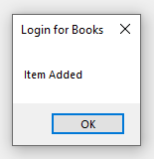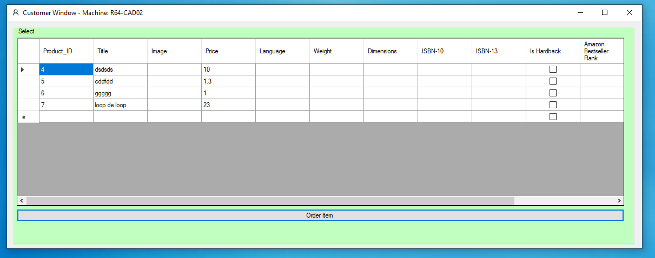 The customer after logging in is greeted by this window. Allowing the customer to select the item they would like. After selecting the item, the customer presses order item to add the item as ordered to the database.

After the ‘Order Item’ button is pressed a confirmation message is displayed.

### Implementation

The items that are available need to retrieve from the database for the customer to be able to mark as wanted and saved to the database.

### Corrections

During the development of my program I encountered a logic error when writing my SQL statements. An example of this occurring is

Dim SQLCommand As String = "SELECT * FROM [Users]"

An incorrect table was listed in the SQL command the intended result was for the products to be listed instead of the users from the database. I amended the code and encountered another syntax error during correction.

Dim SQLCommand As String = "SELECT * FROM [Product]

The syntax error that I encountered was the missing quotation marks at the end of the statement which meant that the program was unable to run. The code was fixed, and a quotation mark was added at the end.

Dim SQLCommand As String = "SELECT * FROM [Product]"

### Final code

Imports System.Data.OleDb

Public Class Customer_Landing

Dim CurrentUserData As Customer ''Stores data about the user that is currently logged in

Dim DBConnection As String = "Provider=Microsoft.Jet.OLEDB.4.0;Data Source=" ''Specifies the databasae engine to be used

Dim DBFilename As String = Login.DBFilePath ''Filepath of the dataabase to be used

Dim dataset As New DataSet ''Database retrieval variables

Dim Data As New OleDbDataAdapter

Private Sub Customer_Landing_Load(sender As Object, e As EventArgs) Handles MyBase.Load ''Window load

'TODO: This line of code loads data into the '_Book_selling_store___Computing_NEADataSet.Product' table.

'Me.ProductTableAdapter.Fill(Me._Book_selling_store___Computing_NEADataSet.Product)

Me.Text = "Customer Window - Machine: " & Environment.MachineName 'Dispays the machine name in the corner of the program's window

Dim SQLCommand As String = "SELECT * FROM [Product]" ''Selects all the items from the database table product

Dim Connection As OleDbConnection = New OleDbConnection(DBConnection & DBFilename) ''Establishes a connection to the database for the data to be retrieved.

Dim command As New OleDbCommand(SQLCommand, Connection) ''Issues the command to be executed on the database

Data = New OleDbDataAdapter(SQLCommand, Connection) ''Saves the data the is obtained

'Connection.Open() 'not needed connection already open

dataset.Clear() ''Clears the table displaying the data to the user

Data.Fill(dataset, "table") ''Data is filled into the datadapter

DataGridView1.DataSource = dataset.Tables("table") ''Fills the user facing data table with the data obtained from the database

Connection.Close() ''Closes the connection to the database

End Sub

Public Sub LoadUserData(ByVal UserDataInput As Customer) ''Loads data bout the user that is logged in into the Current user data variable

CurrentUserData = UserDataInput

End Sub

Private Sub OrderButton_Click(sender As Object, e As EventArgs) Handles OrderButton.Click ''

Dim selectedrow As Integer = GetSelectedRowDBID()

''Update database as ordered and Add user ID

Dim SQLCommand As String = "UPDATE [Product] SET [User_ID] = " & Login.LoggedInUserID & " WHERE [Product_ID] = " & selectedrow

Dim Connection As OleDbConnection = New OleDbConnection(DBConnection & DBFilename) 'Establishes a database connection

Dim Command As New OleDbCommand(SQLCommand, Connection) 'Sends the command to the database

Connection.Open()

Command.ExecuteNonQuery() 'Opens connection to database executes command and then closes the connection.

Connection.Close()

MsgBox("Item Added")

End Sub

Function GetSelectedRowDBID() ''Retrieves the row number of the cell the user has selected.

Dim DatabaseID As Integer = CInt(DataGridView1.CurrentRow.Cells(0).Value)

Return DatabaseID

End Function

'Private Sub SearchButton_Click(sender As Object, e As EventArgs) Handles SearchButton.Click

' Dim SQLCommand As String = ""

' If String.IsNullOrWhiteSpace(TitleBox.Text) Then

' If String.IsNullOrWhiteSpace(PriceBox.Text) Then

' If String.IsNullOrWhiteSpace(ISBNBox.Text) Then

' MsgBox("No search parameters!")

' Else

' ''Search using ISBN box value

' If ISBN.ValidCheck(ISBNBox.Text) = True Then

' SQLCommand = "SELECT [Title] FROM [Product] WHERE [ISBN] = '" & ISBNBox.Text & "'"

' Else

' MsgBox("Valid ISBN number required")

' End If

' End If

' Else

' SQLCommand = "SELECT [Title] FROM [Product] WHERE [Price] = '" & PriceBox.Text & "'"

' ''Search using price box value

' End If

' SQLCommand = "SELECT [Title] FROM [Product] WHERE [Title] = '" & TitleBox.Text & "'"

' Else

' ''Search using the title box value

' End If

' If String.IsNullOrWhiteSpace(SQLCommand) Then

' ''If blank SQL command then do nothing else execute the search SQL command

' Else

' Dim Connection As OleDbConnection = New OleDbConnection(DBConnection & DBFilename)

' Dim command As New OleDbCommand(SQLCommand, Connection)

' Data = New OleDbDataAdapter(SQLCommand, Connection)

' 'Connection.Open() 'not needed connection already open

' dataset.Clear()

' Data.Fill(dataset, "table")

' DataGridView1.DataSource = dataset.Tables("table")

' Connection.Close()

' End If

'End Sub

End Class

## Driver Route Planning Page Implementation

##### Route Calculations

The delivery algorithm is complex and to generate the most efficient solution would require solving the travelling salesman problem. My solution at its simplest would involve only one delivery driver delivering all the packages for each day. The first shortest path would be generated to collect all the items. The second delivery path would then deliver all the collected items. This is the implementation that I will use to solve this problem. There are optimisations that could be implemented like checking if a package can be collected and delivered during the collection route. This would then prevent the driver from having to return to the same point unnecessarily. Preforming this check would also remove a node from the delivery route potentially making the second delivery route calculation more efficient.

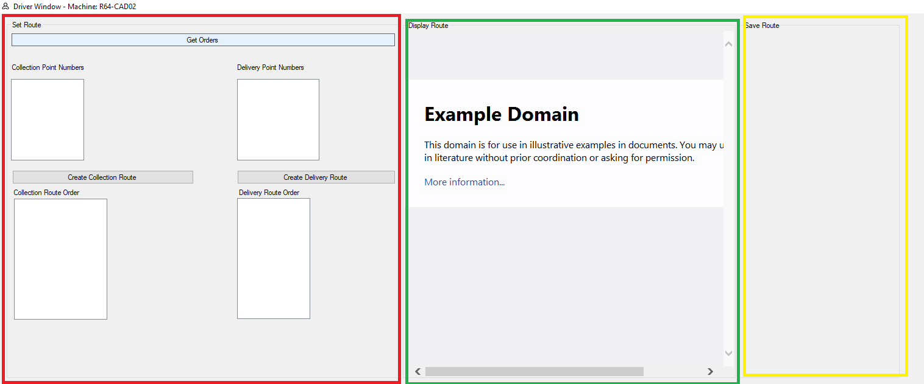

Above is a prototype of the delivery system. The red area represents the route parameters, this includes the delivery and collection point ID’s that must be visited. These points are then organised into a route order. This route order then needs to be cleaned up since if multiple items need to arrive or be collected at the same location that location will be repeated multiple times. This means that repeating points need to be removed as they are unnecessary.

###### Route Map API

API’s will have to be used for navigation (and google maps has been chosen). This will save time developing the program. As the actual physical route navigation will be handled externally. Using an external store of map data will also allow the data to remain accurate e.g. rerouting due to traffic or closed roads. Google maps API allows for a route to be sent as a URL specifying the type of transport used, points to be visited and their order. An example of a URL from Google maps documentation can be found below.

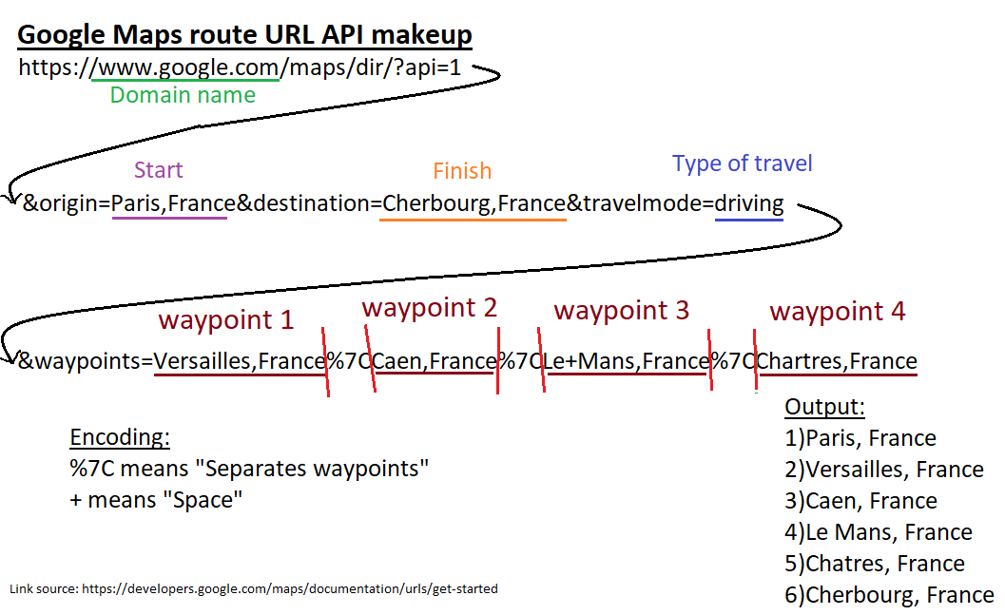This API allows for my ordering algorithm to be used and the specific roads to take between the points is calculated by the API. This makes the ordering important since poorly chosen points can significantly increase journey time.

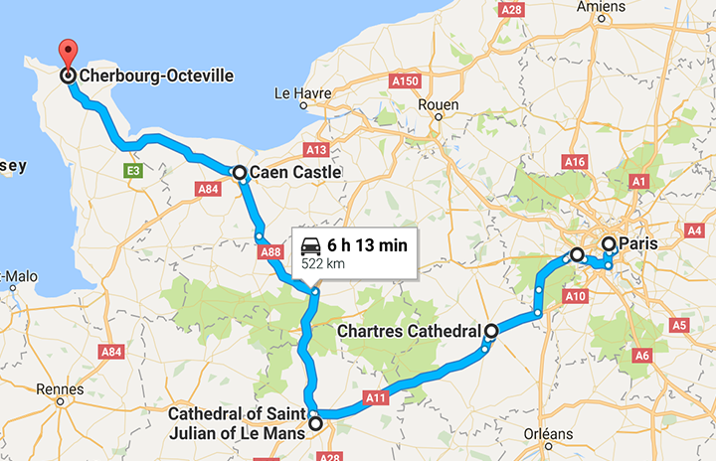

An example of a well-chosen ordering leading to a shorter journey time (Google, 2015)

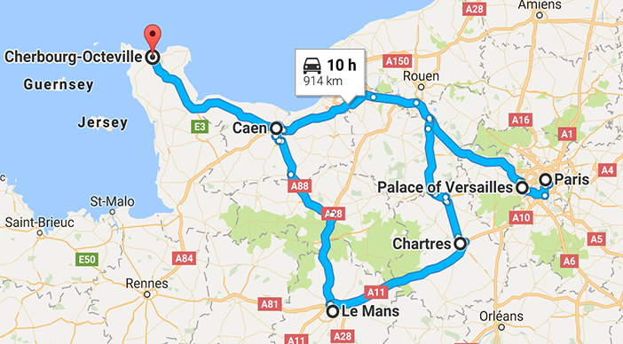

Example of a poorly chosen ordering increasing the journey time by over three hours (Google, 2015)

To implement this API, the path generated needs to be converted into a URL that can then be passed to the vb.net forms integrated web browser to display.

#### Route Display implementation

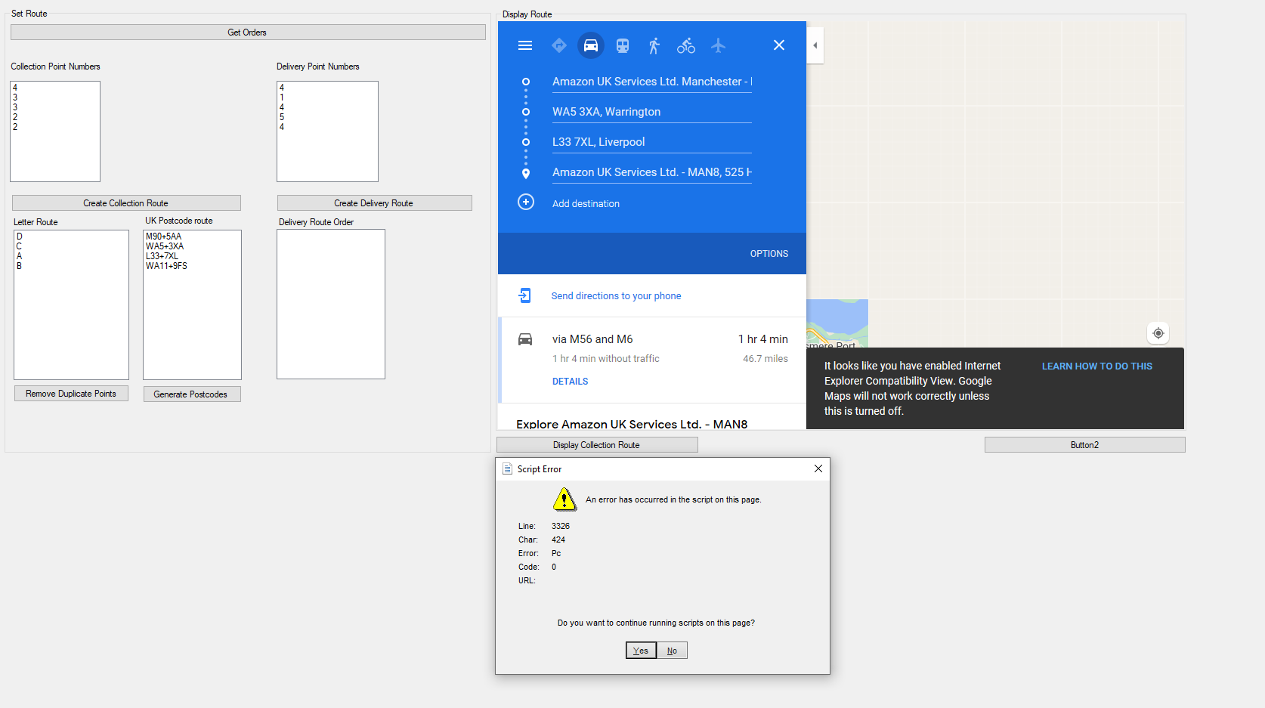

Figure Route Display Window

There are four processes that must be completed before a link with the transport details can be generated. First the collection point numbers must be generated and brought into the windows form. Then the integers are converted into letters which are used in the Dijkstra’s algorithm. This means that repeating points are grouped together and can be removed. The letters generated then need to be converted into postcodes. Then finally the postcodes can be placed into the navigation link.

##### Example

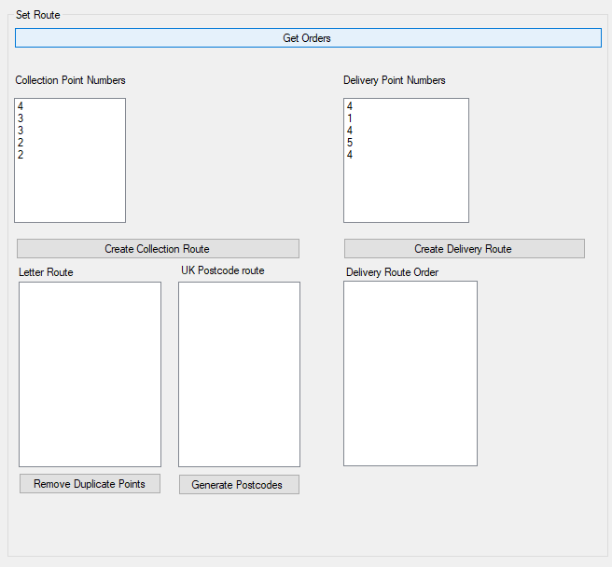

Pressing the “Get Orders” button retrieves the points that need to be generated and are displayed in the collection point numbers box below the button.

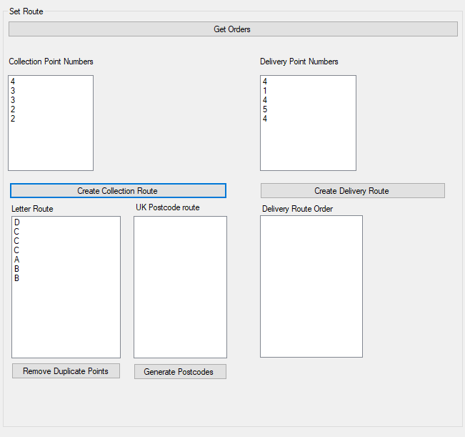

A delivery route is created using the points provided and is displayed in the box labelled “Letter Route”.

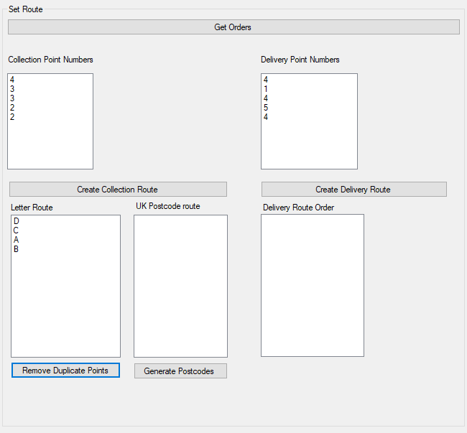

Pressing the button “Remove duplicate points” removes repeating letters from the delivery sequence. This prevents the next location being the driver’s current location.

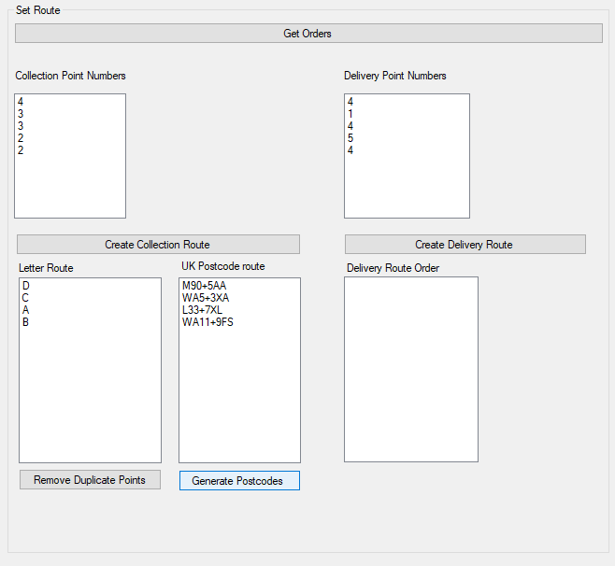

The button “Generate Postcodes” converts the letters in the box labelled “Letter Route” into the postcodes the letters are representing. The output is then displayed in the “UK Postcode Route box”

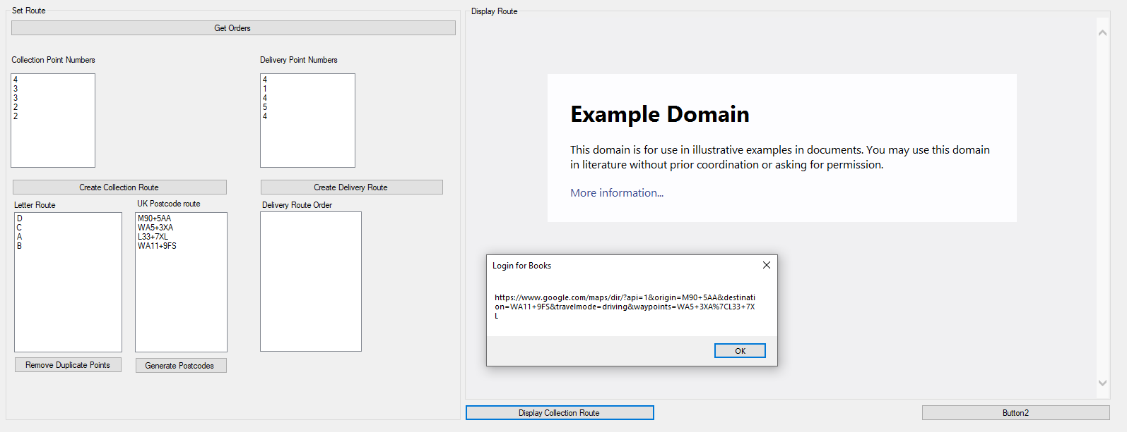The button “Display Collection Route” uses the order of postcodes generated to create a URL to use with the Google Maps API. Unfortunately, the WebBrowser control built into vb.net forms uses internet explorer which does not work well with google maps and is out of my control. Therefore, a message box pops up to copy and paste the link into a different web browser.

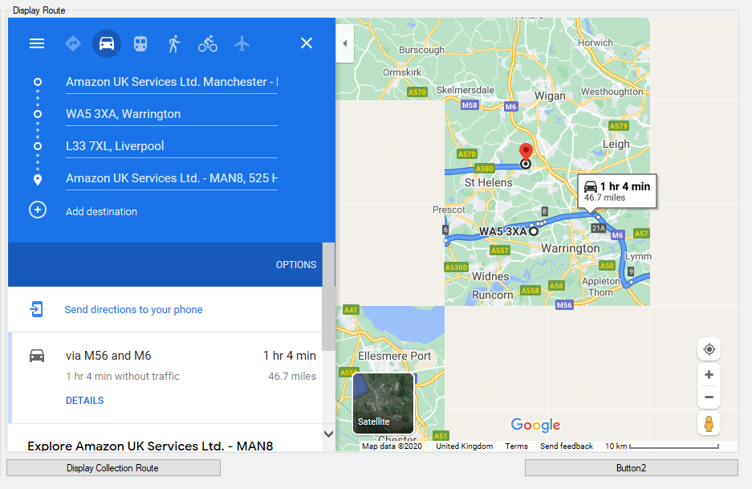

An example of a route being shown inside of the programs built in web browser element. Parts of the map tiles appear to be missing.

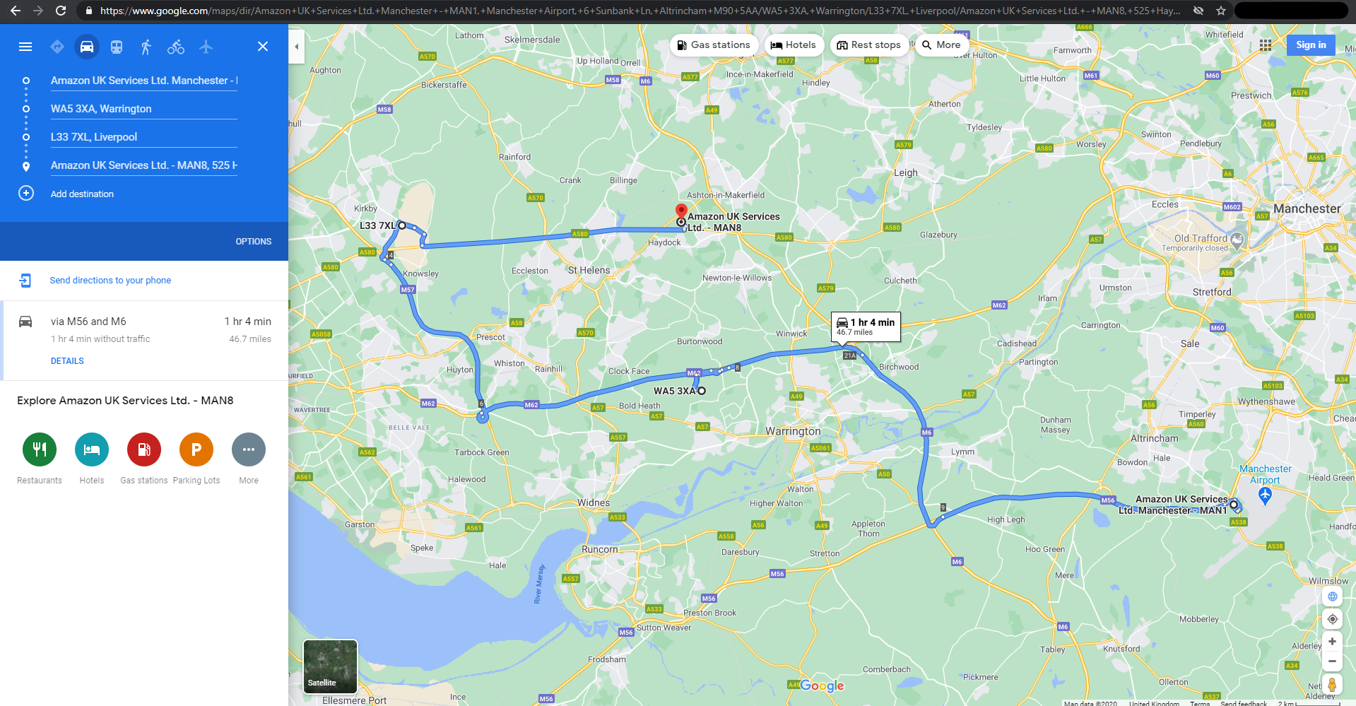

Figure 15 The link generated by the program displayed in a modern web browser

Figure 16 Path chosen by the program’s routing system

<https://www.google.com/maps/dir/?api=1&origin=M90+5AA&destination=WA11+9FS&travelmode=driving&waypoints=WA5+3XA%7CL33+7XL>

The link generated by the program is not the most efficient route below is an example of a more efficient route. This could be because of the weighting used in the program being different to real world road conditions.

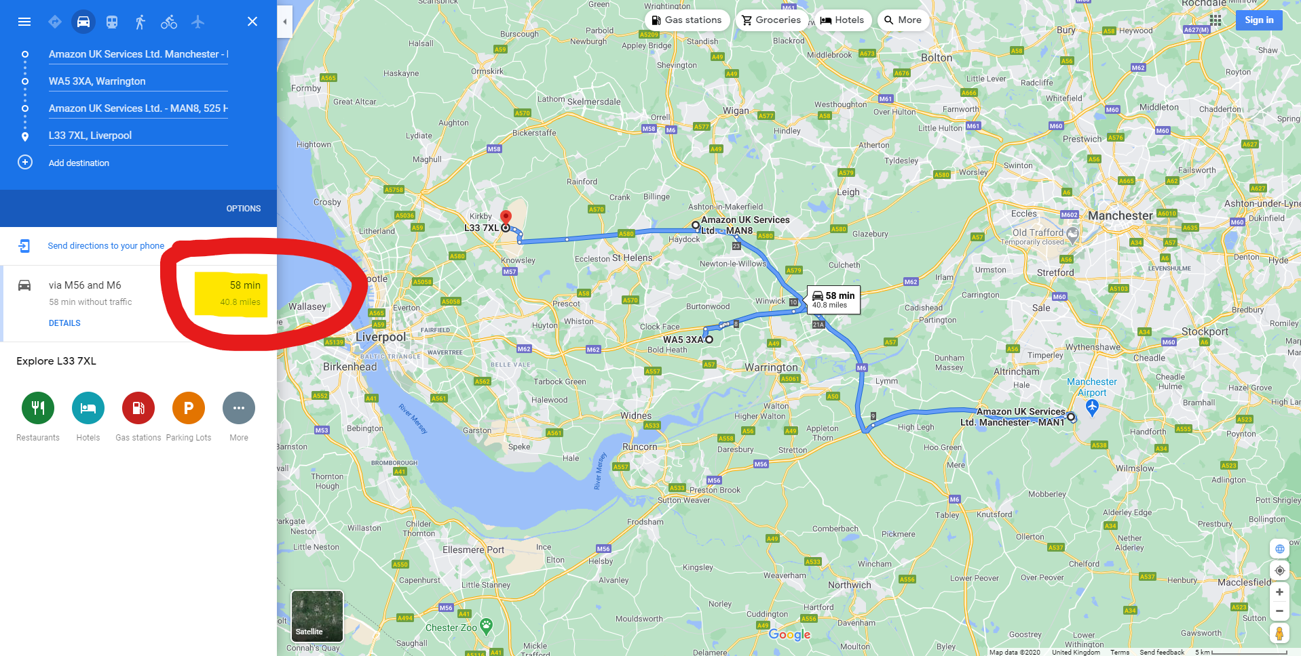

Figure 17 More Efficient routing path which was not chosen



Figure 18 Route Time

## Addition of automate Button

There are many boxes used to show the steps used to create a route which require multiple buttons to be pressed in a linear order. The get route automatically runs the multiple functions to obtain the result without the manual intervention.

## Manager’s Window

The screen is divided into two parts one where the database can be viewed and edited. The left part is to add new items to the database.

### Implementation

#### ISBN Checking

The main source in my research into how ISBN codes are validated has been the ISBN International User’s Manual. (International ISBN Agency, 2017) In the Appendix there is an example ISBN 13 number being checked and the calculations being walked through.

The example ISBN is 978-92-95055-12-?

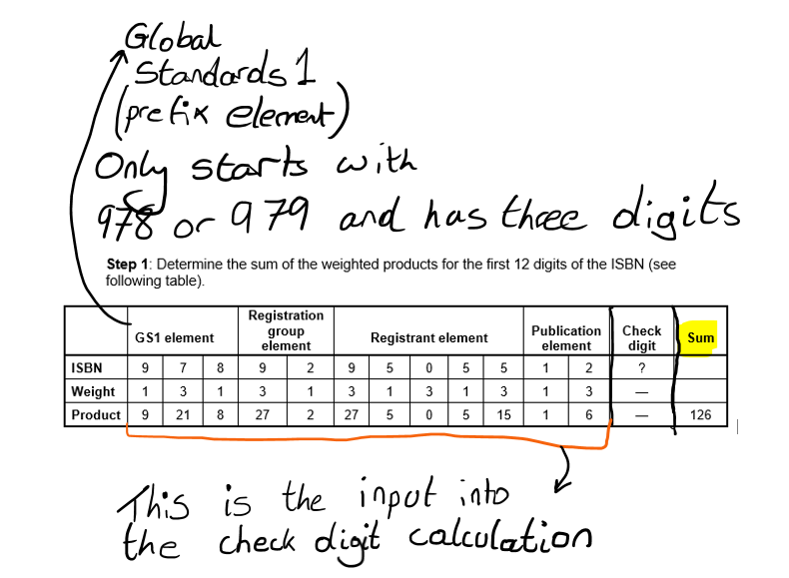

Figure 19 Annotated table calculating the weight and product of an ISBN (International ISBN Agency, 2017)

The next steps are:

**Step 2**: Divide the sum of the weighted products of the first 12 digits of the ISBN calculated in step 1 by 10, determining the remainder. (International ISBN Agency, 2017)

126 / 10 = 12 remainder = 6

The remainder’s are found in this step

**Step 3**: Subtract the remainder calculated in step 2 from 10. The resulting difference is the value of the check digit with one exception. If the remainder from step 2 is 0, the check digit is 0. (International ISBN Agency, 2017)

10 – 6 = 4

Check digit = 4

ISBN = 978-92-95055-12-4

The following mathematical formula is an alternative way of expressing the calculation of the check digit:

Check digit = mod 10 (10 – [mod 10 {sum of weighted products of the first 12 ISBN digits}])

Check digit = mod 10 (10 – [mod 10 {126}])

Check digit = 4

The sum of the weighted products of the first 12 digits plus the check digit must be divisible by 10 without a remainder for the ISBN to be valid. (International ISBN Agency, 2017)

This same process would be applied to ISBN’s being checked in my program the check digit would be ignored and the check digit would be calculated from the other numbers and then compared with the one input by the user at the end of the process to determine if the ISBN number is valid.

##### ISBN Number Checking Module

Imports System.Text.RegularExpressions ''Imports regex expressions

Module ISBN

Public Function ValidCheck(ISBN As String) As Boolean

Dim result = False

If (Not String.IsNullOrWhiteSpace(ISBN)) Then ''Cannot contain blank spaces in the input check

''Remove blanks or dashes in the string that is given

ISBN = ISBN.Replace("-", "").Replace(" ", "")

Select Case ISBN.Length ''Decide is an ISBN 10 or an ISBN 13 Checking routine is required, determined by string length

Case 10 'ISBN 10

result = IsValidISBN10(ISBN)

Case 13 'ISBN 13

result = IsValidISBN13(ISBN)

End Select

End If

Return result

End Function

Private Function IsValidISBN10(ISBN As String) As Boolean

Dim result = False

If Regex.IsMatch(ISBN, "^\d{9}[\d,X]{1}$") Then ''Checks for the first 9 input characters to be numbers and the 10th ot be a number or an "x"

Dim Total = 0

''Add up the first 9 numbers values in the ISBN

For i = 0 To 8

Total += CharToNumber(ISBN.Chars(i)) * (i + 1)

Next

''The final digit in a ISBN is used as a check digit (X represents a 10 value)

If ISBN.Chars(9) = "X"c Then ''"X" is used as a 10 value in the standard

Total += 10

Else

Total += CharToNumber(ISBN.Chars(9)) * 10

End If

result = Total Mod 11 = 0 ''Result has to be exactly divisible by zero to result in a valid ISBN

End If

Return result

End Function

Private Function IsValidISBN13(ISBN As String) As Boolean

Dim result = False

' isbn13 string have 13 chars. All of them should be numbers.

If Regex.IsMatch(ISBN, "^\d{13}$") Then ''Checks for exactly 13 numeric characters (since strings can contain letters, required for ISBN 10)

Dim sum = 0

For i = 0 To ISBN.Length - 1 ''Goes through the input one by one (minus the check digit)

Dim times = 1

If IsOddNumber(i) Then

times = 3

End If

sum += CharToNumber(ISBN.Chars(i)) * times ''Times is 1 for even and 2 for odd

Next

result = sum Mod 10 = 0 ''Result has to be exactly divisible by zero to result in a valid ISBN

End If

Return result

End Function

Private Function CharToNumber(CharInput As Char) As Integer ''letters are turned into numbers to be processed

Return Asc(CharInput) - Asc("0"c)

End Function

Private Function IsOddNumber(NumberToCheck As Integer) As Boolean ''Odd number check

Return NumberToCheck Mod 2 <> 0

End Function

End Module

# Final Code

''Window icon from https://icons8.com/

Imports System.Data

Imports System.Data.OleDb

Public Class Manager_Landing

Dim CurrentUserData As Manager ''Stores the data about the manager that is currently using the program

Dim DBConnection As String = "Provider=Microsoft.Jet.OLEDB.4.0;Data Source="

Dim DBFilename As String = Login.DBFilePath ''Filepath to the database location

Dim index As Integer

Dim dataset As New DataSet

Dim Data As New OleDbDataAdapter

Private Sub Manager_Landing_Load(sender As Object, e As EventArgs) Handles MyBase.Load

'TODO: This line of code loads data into the '_Book_selling_store___Computing_NEADataSet.Warehouse' table.

Me.WarehouseTableAdapter.Fill(Me._Book_selling_store___Computing_NEADataSet.Warehouse) ''Fils

'TODO: This line of code loads data into the '_Book_selling_store___Computing_NEADataSet.Authors' table.

Me.AuthorsTableAdapter.Fill(Me._Book_selling_store___Computing_NEADataSet.Authors)

Me.Text = "Manager Window - Machine: " & Environment.MachineName

PopulateCurrentItems() ''Fills the table that the user sees with items from database

End Sub

Sub PopulateCurrentItems()

Dim Connection As OleDbConnection = New OleDbConnection(DBConnection & DBFilename) ''Specifies connection details

Connection.Open()

Dim SQLCommand As String

SQLCommand = "SELECT * FROM [Product]" ''Selects everything in the table product

Dim command As New OleDbCommand(SQLCommand, Connection) ''Specifies the command and connection to be used

Data = New OleDbDataAdapter(SQLCommand, Connection)

dataset.Clear() ''Clears the dataset in case any previous data is stored

Data.Fill(dataset, "table") ''Data is stored in the dataset

DataGridView1.DataSource = dataset.Tables("table") ''Dataset displayed to the user

Connection.Close()

End Sub

Public Sub LoadUserData(ByVal UserDataInput As Manager) ''Loads data about the user currently logged in into the class

CurrentUserData = UserDataInput

End Sub

Private Sub ClearNewItemFields_Click(sender As Object, e As EventArgs) Handles ClearNewItemFields.Click

''Clears data input fields when "clear" button is pressed

BookISBN.Clear()

BookPrice.Clear()

BookTitle.Clear()

BookWeight.Clear()

End Sub

Private Sub Button1_Click(sender As Object, e As EventArgs) Handles Button1.Click

PopulateCurrentItems()

End Sub

Function GetSelectedRowDBID()

Dim DatabaseID As Integer = CInt(DataGridView1.CurrentRow.Cells(0).Value)

Return DatabaseID

End Function

Private Sub DeleteSelected_Click(sender As Object, e As EventArgs) Handles DeleteSelected.Click

Dim SelectedrowID As Integer = GetSelectedRowDBID()

Dim ConfirmationResult As DialogResult

ConfirmationResult = MessageBox.Show("Are you sure you want to delete selected item?", "Are you sure?", MessageBoxButtons.YesNo, MessageBoxIcon.Question)

''Confirm user choice

If ConfirmationResult = 6 Then 'user confirms option as wanted

Dim SQL As String

SQL = "DELETE * FROM [Product] WHERE [Product_ID] = " & SelectedrowID

Dim connectionstring As String = CurrentUserData.GetConnection()

Dim TemporaryConnection As OleDbConnection = New OleDbConnection(CurrentUserData.GetConnection())

Dim command As New OleDbCommand(SQL, TemporaryConnection)

TemporaryConnection.Open()

command.ExecuteNonQuery()

TemporaryConnection.Close()

MsgBox("Item has been deleted")

End If

''Check that the book is not associated with an order? (optional)

''Create DB command to delete book from the database

End Sub

Private Sub AddNewItem_Click(sender As Object, e As EventArgs) Handles AddNewItem.Click

If ISBN.ValidCheck(BookISBN.Text) = True Then

Dim SQL As String

SQL = "INSERT INTO [Product] ([Title],[Price],[Weight (g)],[ISBN],[Author ID],[User_ID],[Warehouse_ID]) VALUES ('"

SQL = SQL & BookTitle.Text & "', "

SQL = SQL & BookPrice.Text & ", "

SQL = SQL & BookWeight.Text & ", "

SQL = SQL & BookISBN.Text & ", "

SQL = SQL & DataGridView2.CurrentRow.Cells(0).Value & ", "

SQL = SQL & DataGridView3.CurrentRow.Cells(0).Value & ", "

SQL = SQL & "0" & ");" ''UserID = 0 means that the item is not ordered

Dim connectionstring As String = CurrentUserData.GetConnection()

Dim TemporaryConnection As OleDbConnection = New OleDbConnection(CurrentUserData.GetConnection())

Dim command As New OleDbCommand(SQL, TemporaryConnection)

TemporaryConnection.Open()

command.ExecuteNonQuery()

TemporaryConnection.Close()

MsgBox("Item has been added")

Else

MsgBox("Invalid ISBN")

End If

End Sub

End Class

# Testing

The following aspects of the program will require testing:

* Login system
  + Username
  + Password
* Manager System
  + Items in the database displaying onto the grid view
  + Selection and deletion of item from database
  + Allowing addition of items to database
* Customer System
  + Allowing items to be added to the ‘basket’
  + Updating the database with selected details
* Driver System
  + Route Planning
    - Gathering of all customer orders
      * Item
      * Pickup Location
      * Delivery Location
    - Route Calculation
    - Output calculated route
      * Serialising google maps link into API form

## Login System

**Test Plan**

* **Starting Screen**
  + **Registration of new customers**
  + **Login of users**

|  |  |  |  |  |
| --- | --- | --- | --- | --- |
| **Test** | **What will be tested?** | **Normal/Boundary/Erroneous?** | **Expected Result** | **Actual Result (Screenshot)** |
| 1.1 | Registration of new customers | Normal | The customer details are recorded in the database | Screenshot 1.1 |
| 1.2 | Erroneous | No change to the database and a message advising the user of the error is displayed. | Screenshot 1.2 |
| 2.1 | Login of users | Normal | The details are looked up in the database and the user access level is retrieved showing the user a new screen. | Screenshot 2.1 The details are looked up in the database and the users ‘access level’ is retrieved to display the next user. |
| 2.2 | Erroneous | The user details are incorrect, and the user will have an option to try again. | Screenshot 2.2 The user does not match the database since an access level cannot be retrieved from the database an error message is displayed. |
| 3.1 | Database file path selection | Normal | The file path will be saved in the DBFilePath variable. | Screenshot 3.1 A file selection dialog is displayed |
|  |  |  |  |  |

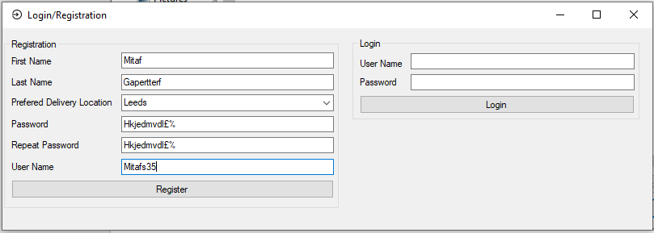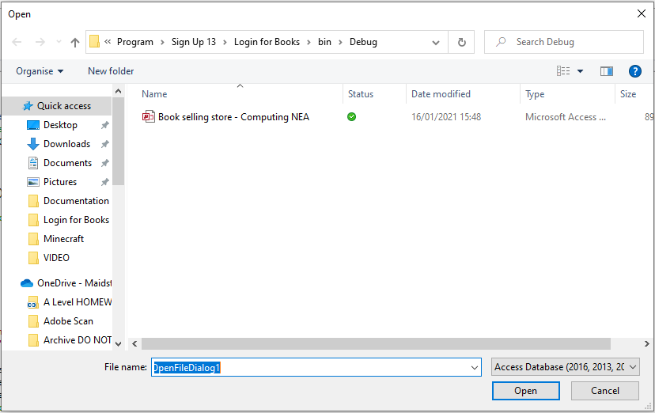

Figure 20 Test Screenshot 1.1

Figure 21 Test Screenshot 3.1

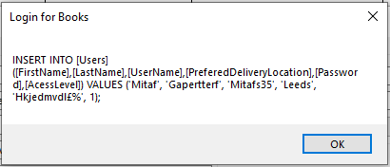

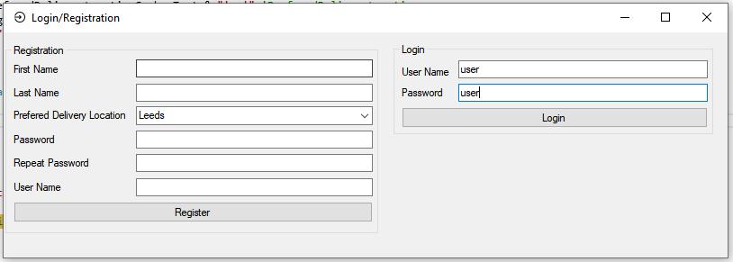Figure 23 Test Screenshot 3.1

Figure 22 Test Screenshot 2.1

* **Manager Screen**
  + **Addition of new items to the database**
  + **Removal of items from the database**

|  |  |  |  |  |
| --- | --- | --- | --- | --- |
| **Test** | **What will be tested?** | **Normal/Boundary/Erroneous?** | **Expected Result** | **Actual result (Screenshot)** |
| 3.1 | Addition of new items to the database | Normal | The items details are recorded in the database | **Figure 27** Example of a confirmation message after adding a new item/book |
| 3.2 | Erroneous | No change to the database and a message advising the user of the error where an incorrect ISBN number is input | **Figure 28** Example of erroneous data being entered into the form and being rejected |
| 5.1 | Removal of items from the database | Normal | The selected row is removed from the database | **Figure 30** Confirmation message being displayed before the item is deleted from the database  **Figure 31** Message confirming that the Item has been deleted  **Figure 32** the item is removed from the list. |
|  |  |  |  |  |

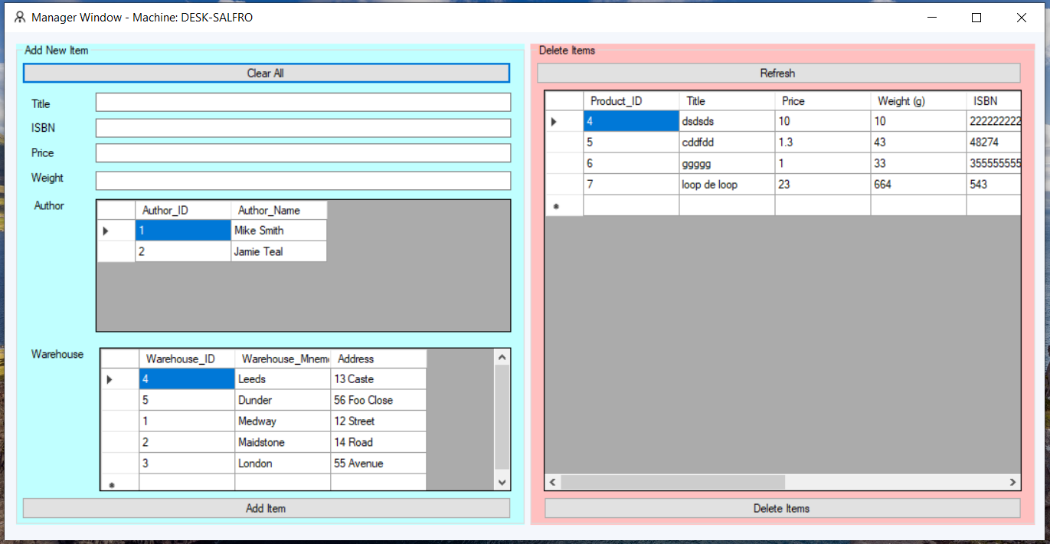

Figure 24 Manager starting screen

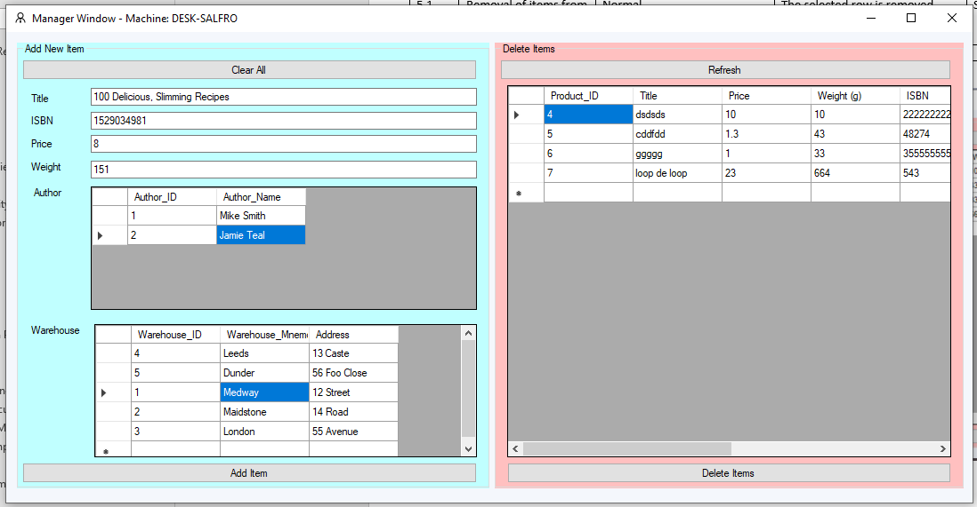Figure 26 Starting screen when opening the window

Figure 25 Example input to add a new book to the program.

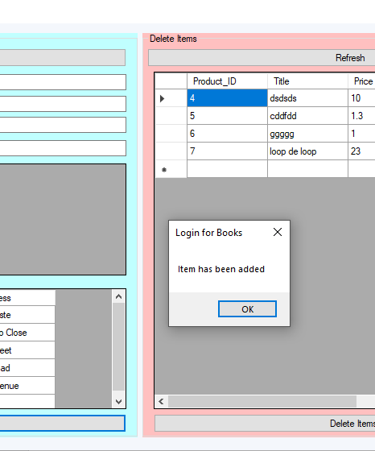

Figure 27 Example of a confirmation message after adding a new item/book

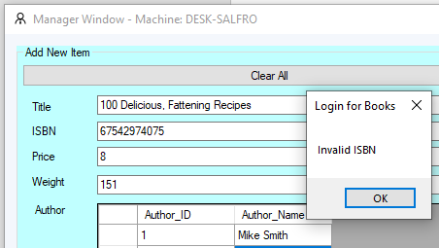

Figure 28 Example of erroneous data being entered into the form and being rejected

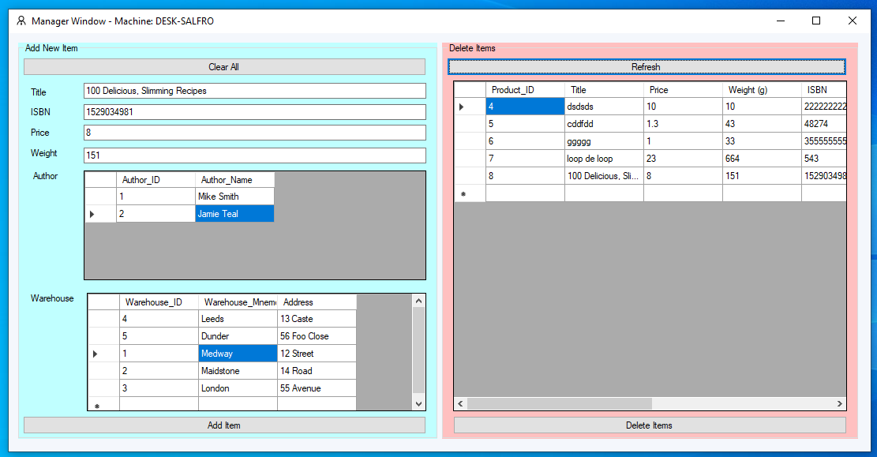

Figure 29 The item that was added being displayed in the item list

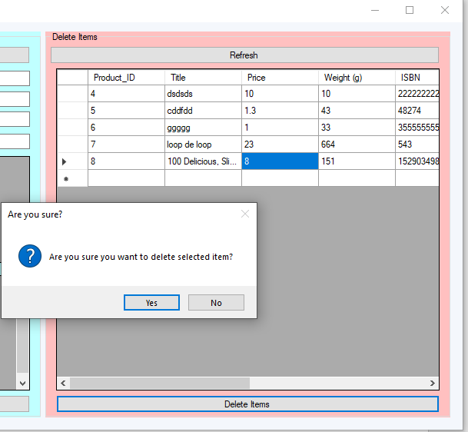

Figure 30 Confirmation message being displayed before the item is deleted from the database

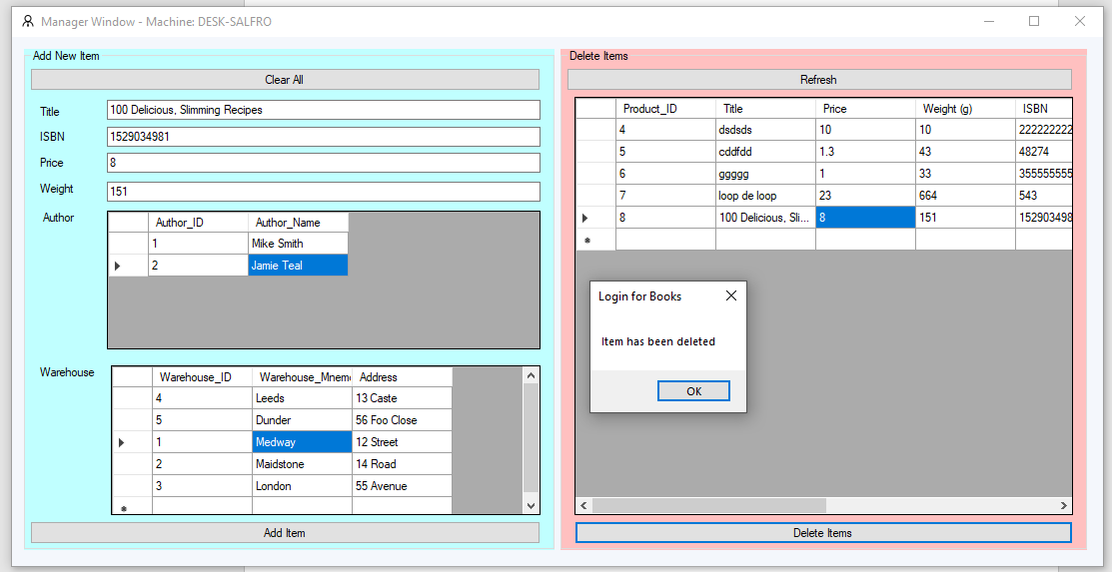

Figure 31 Message confirming that the Item has been deleted

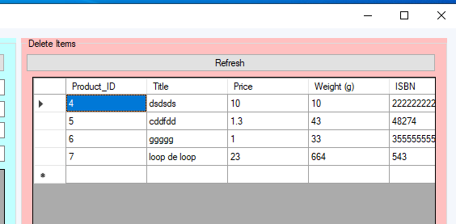

Figure 32 the item is removed from the list.

* **Customer Screen**
  + **Display of items in the database**
  + **Searching items in the database**
  + **Selection of items to be ordered**
  + **Selecting items to be delivered**
  + **Adding the order to the database**

|  |  |  |  |  |
| --- | --- | --- | --- | --- |
| **Test** | **What will be tested?** | **Normal/Boundary/Erroneous?** | **Expected Result** | **Actual result (Screenshot)** |
| 6.1 | Items table is retrieved from the database and displayed to the user | Normal | Data stored in the database is displayed without alteration to the user | Figure 33 Test 6.1 The window loads with the items in the database already displayed |
| 7.2 | When the customer clicks on an item and the presses Order Item The item is marked as ordered in the database | Normal | The item is marked as ordered in the database. | Figure 34 Confirmation message showing that the item has been marked as ordered |
|  |  |  |  |  |

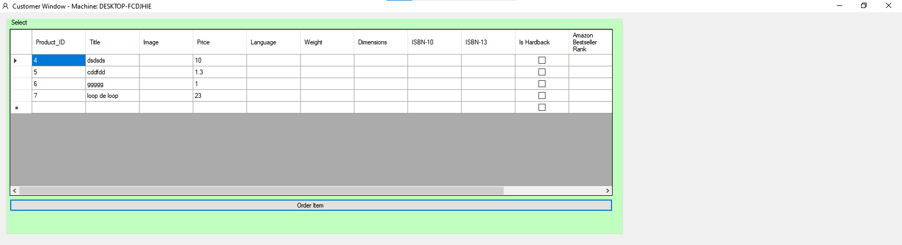

Figure 33 Test 6.1

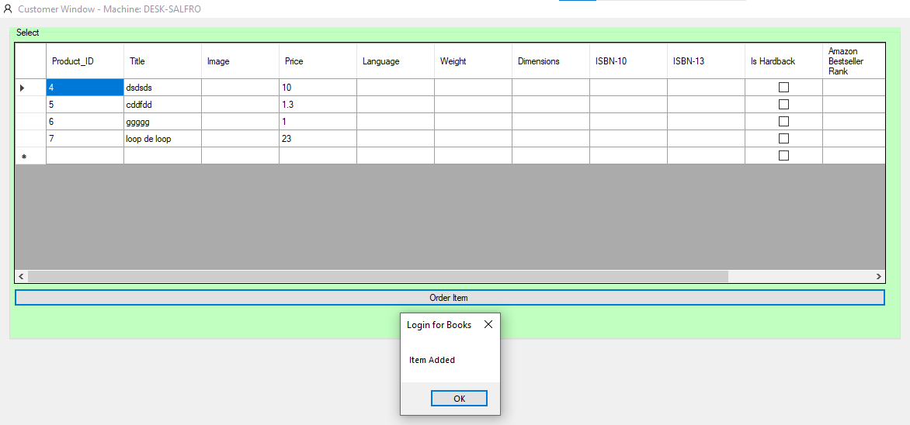

Figure 34 Confirmation message showing that the item has been marked as ordered

* **Driver Screen**
  + **Allowing a delivery route to be calculated from orders that need to be delivered.**

|  |  |  |  |  |
| --- | --- | --- | --- | --- |
| **Test** | **What will be tested?** | **Normal/Boundary/Erroneous?** | **Expected Result** | **Actual Result (screenshot)** |
| 10.1 | Collection/Delivery points to be calculated are displayed on the screen | Normal | 5 Delivery/Collection points are displayed on the screen in a random order. | Screenshot |
| 12.1 | Collection/Delivery point integers converted into letters. | Normal | The integers used to represent the points are converted into numbers. E.g. 1 converted into A | Screenshot |
| 13.1 | Duplicate points should be removed. The duplicate points will now be aligned next to each other. | Normal | Duplicate points will be grouped together allowing for easier removal. E.g. A B B F will turn into A B F | Screenshot |
| 14.1 | The letter delivery route needs to be converted into a list of postcodes. | Normal | The letters are looked up in a list of postcodes and used to create the list of postcodes to visit | Screenshot |
| 15.1 | The postcodes are used to create a google map link to show the delivery route visually by generating a google maps link. The link is displayed in a message box. | Normal | The google maps link is displayed. | Screenshot |
| 16.1 | Ensure that the automatic button that generates the route without going through the individual steps is working correctly. | Normal | The process of generating a route is completed successfully. | Screenshot |
|  |  |  |  |  |

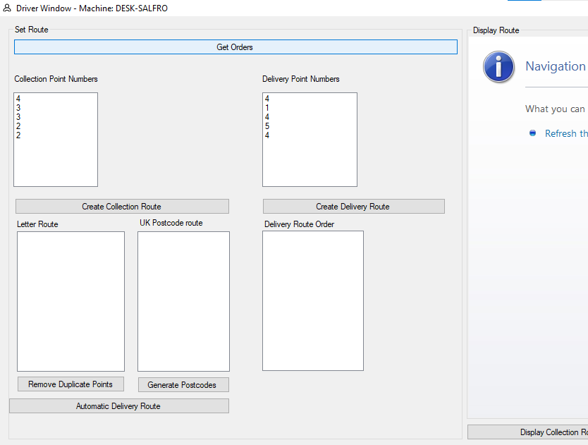

Figure 35 Test 10.1

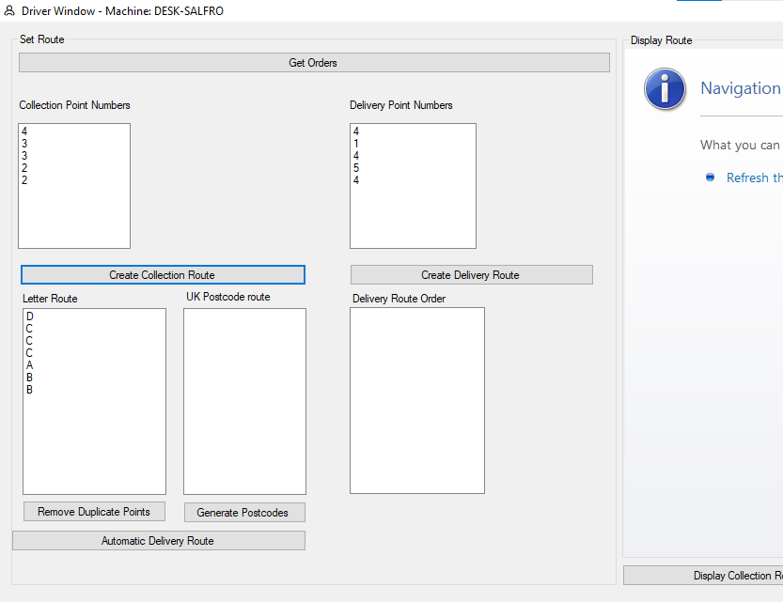

Figure 36 Test 11.1

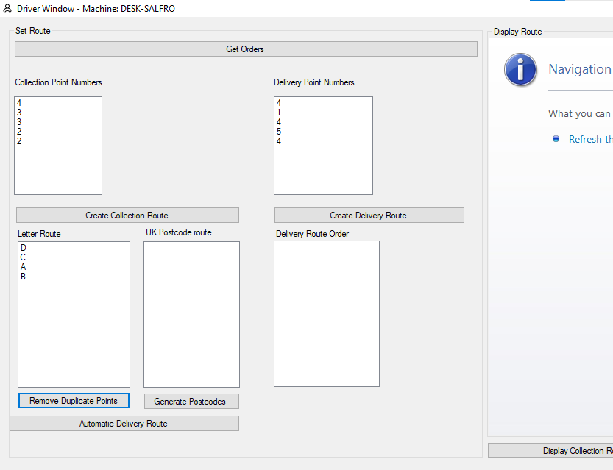

Figure 37 Test 13.1

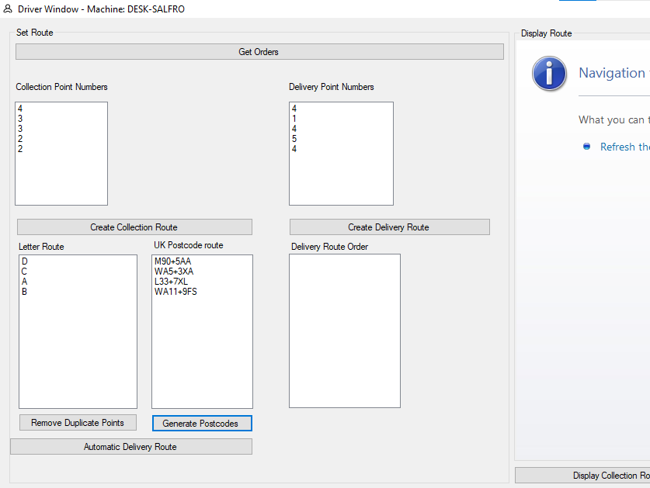

Figure 38 Test 15.1

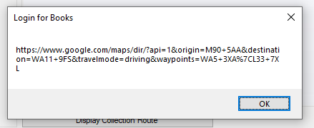

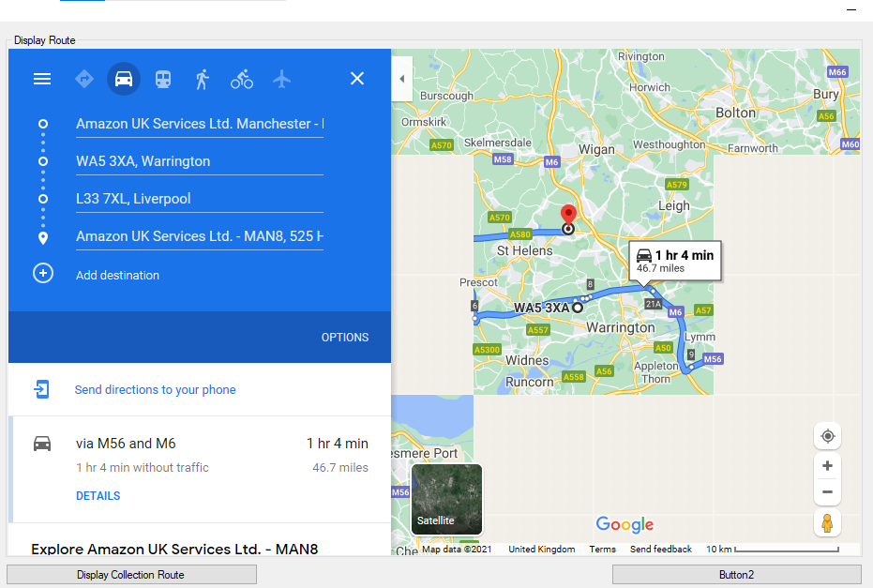Figure 40 Test 16.1 Link generated by the program being displayed as a message

Figure 39 Test 17.1 Display of route in program with missing tiles due to a web browser limitation.

# Evaluation

### Login Screen

The screen introducing users to the login and registration process was intuitively spilt up into a left registration process and a right login process. There were no improvements suggested here and the program worked as intended.

##### Registration of new users

The form fills out from top to bottom with an action button at the bottom. This saves the users details and allows then to login on the same page. This was created well with no complaints.

### Item Manager Screen

##### Viewing of existing items in the Database

The items are viewed from the database and the selection of an item is simple and intuitive with a point and click method of selecting the wanted item. The selection is then confirmed with a button located at the bottom of the window which was not immediately obvious after selecting the item but was discovered after realizing that no indication that the item was ordered had been received. An improvement to the system was suggested that the items ordered should be marked in some way to make them distinguishable.

##### Addition of new items to the database

The customer self ‘registers’ a login to the system to the database on the first screen that is seen by the user. The screen is simple to fill out with a vertically downwards flow of details that need to be filled out. The

### Customer Ordering Screen

##### Viewing of items that are available

The items in the database display correctly the items can be found from the list as intended.

##### Marking items as wanted

The criticism received is that items that have been marked as ordered would not be marked on screen as being ordered leading to confusion over whether the item had been ordered. A confirmation popup was added to reduce confusion, although the information should be displayed in a more intuitive way something which I did not have time to do as it did not impact the functioning of the program. Otherwise the items are marked as ordered in the database as intended.

### Driver Route Creation window

The driver route window is divided into two parts there the driver generates the route and can view how the route is created and then view the route itself in the second window.

##### Creation of route

The route creation process goes through multiple stages which can become tiresome to click through therefore an automatic button was added to speed up the process. This meant that the process could be sped up while allowing the steps in the process to be explained.

### *Evaluating the routing system* *chosen*

The routing system uses the generated points as input into the pathfinding algorithm. The input goes through multiple processes where the input is converted into other data formats. This led to the automatic route creation button to be added which reduced route planning to a single click. This reduced the time required to create a route.

Unfortunately (as shown in “Figure 17 More Efficient routing path which was not chosen”), there appears to be a more efficient route in terms of time and distance covered. Since I am using time as my weighting between points using distance between points could have been more appropriate since road length is likely to stay constant day to day compared to the time taken to travel on any given day. Although fundamentally the problem here is that my weightings remain constant while road conditions are changing. To better correct this issue, I would have to update my weightings each time the graph is run. This would allow the program to have an accurate model of road conditions before planning a route.

##### Display of route

The route is displayed in the built-in web browser and the link is displayed for viewing in another web browser which works better since map tiles do not disappear. Unfortunately, due to the technical problems the route displayed in the program does not work well, although opening the link in another web browser has been an acceptable although not ideal solution.

# Final Code

##### Customer.vb

Public Class Customer

Inherits User

Private PreferedDeliveryLocationKey As Integer 'Key to another table in DB

Sub SetPreferedDeliveryLocationKey(ByVal LocationKeyInput As Integer)

PreferedDeliveryLocationKey = LocationKeyInput

End Sub

Public Function GetPreferedDeliveryLocationKey()

Return PreferedDeliveryLocationKey

End Function

End Class

##### Customer_Landing.vb

Imports System.Data.OleDb

Public Class Customer_Landing

Dim CurrentUserData As Customer ''Stores data about the user that is currently logged in

Dim DBConnection As String = "Provider=Microsoft.Jet.OLEDB.4.0;Data Source=" ''Specifies the databasae engine to be used

Dim DBFilename As String = Login.DBFilePath ''Filepath of the dataabase toi be used

Dim dataset As New DataSet ''Database retrieval variables

Dim Data As New OleDbDataAdapter

Private Sub Customer_Landing_Load(sender As Object, e As EventArgs) Handles MyBase.Load ''Window load

'TODO: This line of code loads data into the '_Book_selling_store___Computing_NEADataSet.Product' table.

'Me.ProductTableAdapter.Fill(Me._Book_selling_store___Computing_NEADataSet.Product)

Me.Text = "Customer Window - Machine: " & Environment.MachineName 'Dispays the machine name in the corner of the program's window

Dim SQLCommand As String = "SELECT * FROM [Product]" ''Selects all of the items from the database table product

Dim Connection As OleDbConnection = New OleDbConnection(DBConnection & DBFilename) ''Establishes a connection to the database for the data to be retrieved.

Dim command As New OleDbCommand(SQLCommand, Connection) ''Issues the command to be executed on the database

Data = New OleDbDataAdapter(SQLCommand, Connection) ''Saves the data the is obtained

'Connection.Open() 'not needed connection already open

dataset.Clear() ''Clears the table displaying the data to the user

Data.Fill(dataset, "table") ''Data is filled into the datadapter

DataGridView1.DataSource = dataset.Tables("table") ''Fills the user facing data table with the data obtained from the database

Connection.Close() ''Closes the connection to the database

End Sub

Public Sub LoadUserData(ByVal UserDataInput As Customer) ''Loads data bout the user that is logged in into the Current user data variable

CurrentUserData = UserDataInput

End Sub

Private Sub OrderButton_Click(sender As Object, e As EventArgs) Handles OrderButton.Click ''

Dim selectedrow As Integer = GetSelectedRowDBID()

''Update database as ordered and Add user ID

Dim SQLCommand As String = "UPDATE [Product] SET [User_ID] = " & Login.LoggedInUserID & " WHERE [Product_ID] = " & selectedrow

Dim Connection As OleDbConnection = New OleDbConnection(DBConnection & DBFilename) 'Establishes a database connection

Dim Command As New OleDbCommand(SQLCommand, Connection) 'Sends the command to the database

Connection.Open()

Command.ExecuteNonQuery() 'Opens connection to database extecutes command and then closes the connection.

Connection.Close()

MsgBox("Item Added")

End Sub

Function GetSelectedRowDBID() ''Retrieves the row number of the cell the user has selected.

Dim DatabaseID As Integer = CInt(DataGridView1.CurrentRow.Cells(0).Value)

Return DatabaseID

End Function

'Private Sub SearchButton_Click(sender As Object, e As EventArgs) Handles SearchButton.Click

' Dim SQLCommand As String = ""

' If String.IsNullOrWhiteSpace(TitleBox.Text) Then

' If String.IsNullOrWhiteSpace(PriceBox.Text) Then

' If String.IsNullOrWhiteSpace(ISBNBox.Text) Then

' MsgBox("No search parameters!")

' Else

' ''Search using ISBN box value

' If ISBN.ValidCheck(ISBNBox.Text) = True Then

' SQLCommand = "SELECT [Title] FROM [Product] WHERE [ISBN] = '" & ISBNBox.Text & "'"

' Else

' MsgBox("Valid ISBN number required")

' End If

' End If

' Else

' SQLCommand = "SELECT [Title] FROM [Product] WHERE [Price] = '" & PriceBox.Text & "'"

' ''Search using price box value

' End If

' SQLCommand = "SELECT [Title] FROM [Product] WHERE [Title] = '" & TitleBox.Text & "'"

' Else

' ''Search using the title box value

' End If

' If String.IsNullOrWhiteSpace(SQLCommand) Then

' ''If blank SQL command then do nothing else execute the search SQL command

' Else

' Dim Connection As OleDbConnection = New OleDbConnection(DBConnection & DBFilename)

' Dim command As New OleDbCommand(SQLCommand, Connection)

' Data = New OleDbDataAdapter(SQLCommand, Connection)

' 'Connection.Open() 'not needed connection already open

' dataset.Clear()

' Data.Fill(dataset, "table")

' DataGridView1.DataSource = dataset.Tables("table")

' Connection.Close()

' End If

'End Sub

End Class

##### Driver.vb

Public Class Driver

Inherits User

End Class

##### Driver_Landing.vb

Public Class Driver_Landing ''Drivers route window

Dim CurrentUserData As Driver ''Data about current user stored here

Dim Nodecount As Integer

Dim totalnodes As Integer

Dim shortest_path1 ''Paths between nodes stored here

Dim shortest_path2

Dim shortest_path3

Dim shortest_path4

Private Sub Driver_Landing_Load(sender As Object, e As EventArgs) Handles MyBase.Load

'TODO: This line of code loads data into the '_Book_selling_store___Computing_NEADataSet.Product' table. You can move, or remove it, as needed.

Me.Text = "Driver Window - Machine: " & Environment.MachineName

WebBrowser1.Navigate(New Uri("http://www.maps.google.com")) ''Web browser URL Navigation

WebBrowser1.Update()

End Sub

Dim CollectionPoints(5) As Integer ''Array to store 5 points marked for collection

Dim DeliveryPoints(5) As Integer ''Array to store 5 points marked for delivery

Public Sub LoadUserData(ByVal UserDataInput As Driver) ''Loads data about the user into currrentuserdata

CurrentUserData = UserDataInput

End Sub

Sub GetCollectionPoints() ''The collection points to be used in pathfinding.

CollectionPoints(1) = Int((5 - 1 + 1) * Rnd() + 1)

CollectionPoints(2) = Int((5 - 1 + 1) * Rnd() + 1)

CollectionPoints(3) = Int((5 - 1 + 1) * Rnd() + 1)

CollectionPoints(4) = Int((5 - 1 + 1) * Rnd() + 1)

CollectionPoints(5) = Int((5 - 1 + 1) * Rnd() + 1)

End Sub

Sub GetDeliveryPoints() ''The delivery points to be used in pathfinding.

DeliveryPoints(1) = Int((5 - 1 + 1) * Rnd() + 1)

DeliveryPoints(2) = Int((5 - 1 + 1) * Rnd() + 1)

DeliveryPoints(3) = Int((5 - 1 + 1) * Rnd() + 1)

DeliveryPoints(4) = Int((5 - 1 + 1) * Rnd() + 1)

DeliveryPoints(5) = Int((5 - 1 + 1) * Rnd() + 1)

End Sub

Private Sub GetOrders_Click(sender As Object, e As EventArgs) Handles GetOrders.Click

GetCollectionPoints()

CollectionBox.Items.Clear() 'Clears the box displaying collection points to the user

CollectionBox.Items.Add(CollectionPoints(1)) 'Adds each point to the collection point display.

CollectionBox.Items.Add(CollectionPoints(2))

CollectionBox.Items.Add(CollectionPoints(3))

CollectionBox.Items.Add(CollectionPoints(4))

CollectionBox.Items.Add(CollectionPoints(5))

GetDeliveryPoints()

DeliveryBox.Items.Clear()

DeliveryBox.Items.Add(DeliveryPoints(1))

DeliveryBox.Items.Add(DeliveryPoints(2))

DeliveryBox.Items.Add(DeliveryPoints(3))

DeliveryBox.Items.Add(DeliveryPoints(4))

DeliveryBox.Items.Add(DeliveryPoints(5))

End Sub

Sub GetCollectionPath()

Dim done As Boolean = False

If done = False Then

Dim Path(999) As String

'Path for 1st item in array to 2nd

'Path for 2nd item in array to 3rd

'Path for 3rd item in array to 4th

'Path for 4th item in array to 5th

Dim AlphabetPositionIntegers As New List(Of String)

AlphabetPositionIntegers.Add("A")

AlphabetPositionIntegers.Add("B")

AlphabetPositionIntegers.Add("C")

AlphabetPositionIntegers.Add("D")

AlphabetPositionIntegers.Add("E")

Dim CP1 As String ''Collection point 1

CP1 = AlphabetPositionIntegers(CollectionPoints(1) - 1) ''Converts the integers into a letter code

Dim CP2 As String

CP2 = AlphabetPositionIntegers.Item(CollectionPoints(2) - 1)

Dim CP3 As String

CP3 = AlphabetPositionIntegers.Item(CollectionPoints(3) - 1)

Dim CP4 As String

CP4 = AlphabetPositionIntegers.Item(CollectionPoints(4) - 1)

Dim CP5 As String

CP5 = AlphabetPositionIntegers.Item(CollectionPoints(5) - 1)

path1to2Collection()

path2to3Collection()

path3to4Collection()

path4to5Collection()

totalnodes = Nodecount

RouteOrderBox.Items.Clear()

For Each vertex In shortest_path1

Nodecount = Nodecount + 1

Path(Nodecount) = vertex

RouteOrderBox.Items.Add(vertex)

Next

For Each vertex In shortest_path2

Nodecount = Nodecount + 1

Path(Nodecount) = vertex

RouteOrderBox.Items.Add(vertex)

Next

For Each vertex In shortest_path3

Nodecount = Nodecount + 1

Path(Nodecount) = vertex

RouteOrderBox.Items.Add(vertex)

Next

For Each vertex In shortest_path4

Nodecount = Nodecount + 1

Path(Nodecount) = vertex

RouteOrderBox.Items.Add(vertex)

Next

''Print the contents of the string array "path" into "routeorderbox"

Else

End If

'Nodecount = 1

'Dim strinhjg

'While Nodecount <> totalnodes + 1

' strinhjg = Path(Nodecount)

' RouteOrderBox.Items.Add()

' Nodecount = Nodecount + 1

'End While

done = True

End Sub

Sub GetDeliveryPath()

Dim done As Boolean = False

If done = False Then

Dim Path(999) As String

'Path for 1st item in array to 2nd

'Path for 2nd item in array to 3rd

'Path for 3rd item in array to 4th

'Path for 4th item in array to 5th

Dim AlphabetPositionIntegers As New List(Of String)

AlphabetPositionIntegers.Add("A")

AlphabetPositionIntegers.Add("B")

AlphabetPositionIntegers.Add("C")

AlphabetPositionIntegers.Add("D")

AlphabetPositionIntegers.Add("E")

Dim CP1 As String ''Delivery point 1

CP1 = AlphabetPositionIntegers(DeliveryPoints(1) - 1) ''Converts the integers into a letter code

Dim CP2 As String

CP2 = AlphabetPositionIntegers.Item(DeliveryPoints(2) - 1)

Dim CP3 As String

CP3 = AlphabetPositionIntegers.Item(DeliveryPoints(3) - 1)

Dim CP4 As String

CP4 = AlphabetPositionIntegers.Item(DeliveryPoints(4) - 1)

Dim CP5 As String

CP5 = AlphabetPositionIntegers.Item(DeliveryPoints(5) - 1)

path1to2Delivery()

path2to3Delivery()

path3to4Delivery()

path4to5Delivery()

totalnodes = Nodecount

RouteOrderBox.Items.Clear()

For Each vertex In shortest_path1

Nodecount = Nodecount + 1

Path(Nodecount) = vertex

RouteOrderBox.Items.Add(vertex)

Next

For Each vertex In shortest_path2

Nodecount = Nodecount + 1

Path(Nodecount) = vertex

RouteOrderBox.Items.Add(vertex)

Next

For Each vertex In shortest_path3

Nodecount = Nodecount + 1

Path(Nodecount) = vertex

RouteOrderBox.Items.Add(vertex)

Next

For Each vertex In shortest_path4

Nodecount = Nodecount + 1

Path(Nodecount) = vertex

RouteOrderBox.Items.Add(vertex)

Next

''Print the contents of the string array "path" into "routeorderbox"

Else

End If

'Nodecount = 1

'Dim strinhjg

'While Nodecount <> totalnodes + 1

' strinhjg = Path(Nodecount)

' RouteOrderBox.Items.Add()

' Nodecount = Nodecount + 1

'End While

done = True

End Sub

Sub path1to2Collection()

Dim graph = New Dictionary(Of String, Dictionary(Of String, Integer)) From {

{"A", New Dictionary(Of String, Integer) From {{"B", 4}, {"C", 3}, {"D", 2}}},

{"B", New Dictionary(Of String, Integer) From {{"A", 4}, {"E", 4}}},

{"C", New Dictionary(Of String, Integer) From {{"A", 3}, {"D", 1}}},

{"D", New Dictionary(Of String, Integer) From {{"A", 2}, {"C", 1}, {"F", 2}}},

{"E", New Dictionary(Of String, Integer) From {{"B", 4}, {"G", 2}}},

{"F", New Dictionary(Of String, Integer) From {{"D", 2}, {"G", 5}}},

{"G", New Dictionary(Of String, Integer) From {{"E", 2}, {"F", 5}}}

}

''Stores distances between nodes

''Conversion of integers into Strings is required for the pathfinding algoritmn

Dim done As Boolean = False

If done = False Then

Dim Path(99) As String

'Path for 1st item in array with 2nd

'Path for 2nd item in array with 3rd

'Path for 3rd item in array with 4th

'Path for 4th item in array with 5th

Dim AlphabetPositionIntegers As New List(Of String)

AlphabetPositionIntegers.Add("A")

AlphabetPositionIntegers.Add("B")

AlphabetPositionIntegers.Add("C")

AlphabetPositionIntegers.Add("D")

AlphabetPositionIntegers.Add("E")

Dim CP1 As String

CP1 = AlphabetPositionIntegers(CollectionPoints(1) - 1) ''Integer collection point needs to be converted into a letter code

Dim CP2 As String

CP2 = AlphabetPositionIntegers.Item(CollectionPoints(2) - 1)

Dim CP3 As String

CP3 = AlphabetPositionIntegers.Item(CollectionPoints(3) - 1)

Dim CP4 As String

CP4 = AlphabetPositionIntegers.Item(CollectionPoints(4) - 1)

Dim CP5 As String

CP5 = AlphabetPositionIntegers.Item(CollectionPoints(5) - 1)

shortest_path1 = dijkstra1(graph, CP1, CP2)

For Each vertex In shortest_path1

Nodecount = Nodecount + 1

Path(Nodecount) = vertex

Next

Else

End If

End Sub

Sub path1to2Delivery()

Dim graph = New Dictionary(Of String, Dictionary(Of String, Integer)) From {

{"A", New Dictionary(Of String, Integer) From {{"B", 4}, {"C", 3}, {"D", 2}}},

{"B", New Dictionary(Of String, Integer) From {{"A", 4}, {"E", 4}}},

{"C", New Dictionary(Of String, Integer) From {{"A", 3}, {"D", 1}}},

{"D", New Dictionary(Of String, Integer) From {{"A", 2}, {"C", 1}, {"F", 2}}},

{"E", New Dictionary(Of String, Integer) From {{"B", 4}, {"G", 2}}},

{"F", New Dictionary(Of String, Integer) From {{"D", 2}, {"G", 5}}},

{"G", New Dictionary(Of String, Integer) From {{"E", 2}, {"F", 5}}}

}

''Stores distances between nodes

''Conversion of integers into Strings is required for the pathfinding algoritmn

Dim done As Boolean = False

If done = False Then

Dim Path(99) As String

'Path for 1st item in array with 2nd

'Path for 2nd item in array with 3rd

'Path for 3rd item in array with 4th

'Path for 4th item in array with 5th

Dim AlphabetPositionIntegers As New List(Of String)

AlphabetPositionIntegers.Add("A")

AlphabetPositionIntegers.Add("B")

AlphabetPositionIntegers.Add("C")

AlphabetPositionIntegers.Add("D")

AlphabetPositionIntegers.Add("E")

Dim CP1 As String

CP1 = AlphabetPositionIntegers(DeliveryPoints(1) - 1) ''Integer delivery point needs to be converted into a letter code

Dim CP2 As String

CP2 = AlphabetPositionIntegers.Item(DeliveryPoints(2) - 1)

Dim CP3 As String

CP3 = AlphabetPositionIntegers.Item(DeliveryPoints(3) - 1)

Dim CP4 As String

CP4 = AlphabetPositionIntegers.Item(DeliveryPoints(4) - 1)

Dim CP5 As String

CP5 = AlphabetPositionIntegers.Item(DeliveryPoints(5) - 1)

shortest_path1 = dijkstra1(graph, CP1, CP2)

For Each vertex In shortest_path1

Nodecount = Nodecount + 1

Path(Nodecount) = vertex

Next

Else

End If

End Sub

Sub path2to3Collection()

Dim graph = New Dictionary(Of String, Dictionary(Of String, Integer)) From {

{"A", New Dictionary(Of String, Integer) From {{"B", 4}, {"C", 3}, {"D", 2}}},

{"B", New Dictionary(Of String, Integer) From {{"A", 4}, {"E", 4}}},

{"C", New Dictionary(Of String, Integer) From {{"A", 3}, {"D", 1}}},

{"D", New Dictionary(Of String, Integer) From {{"A", 2}, {"C", 1}, {"F", 2}}},

{"E", New Dictionary(Of String, Integer) From {{"B", 4}, {"G", 2}}},

{"F", New Dictionary(Of String, Integer) From {{"D", 2}, {"G", 5}}},

{"G", New Dictionary(Of String, Integer) From {{"E", 2}, {"F", 5}}}

}

Dim done As Boolean = False

If done = False Then

Dim Path(99999) As String

'Path for 1st item in array with 2nd

'Path for 2nd item in array with 3rd

'Path for 3rd item in array with 4th

'Path for 4th item in array with 5th

Dim AlphabetPositionIntegers As New List(Of String)

AlphabetPositionIntegers.Add("A")

AlphabetPositionIntegers.Add("B")

AlphabetPositionIntegers.Add("C")

AlphabetPositionIntegers.Add("D")

AlphabetPositionIntegers.Add("E")

Dim CP1 As String

CP1 = AlphabetPositionIntegers(CollectionPoints(1) - 1)

Dim CP2 As String

CP2 = AlphabetPositionIntegers.Item(CollectionPoints(2) - 1)

Dim CP3 As String

CP3 = AlphabetPositionIntegers.Item(CollectionPoints(3) - 1)

Dim CP4 As String

CP4 = AlphabetPositionIntegers.Item(CollectionPoints(4) - 1)

Dim CP5 As String

CP5 = AlphabetPositionIntegers.Item(CollectionPoints(5) - 1)

shortest_path2 = dijkstra2(graph, CP2, CP3)

For Each vertex In shortest_path2

Nodecount = Nodecount + 1

Path(Nodecount) = vertex

Next

Else

End If

End Sub

Sub path2to3Delivery()

Dim graph = New Dictionary(Of String, Dictionary(Of String, Integer)) From {

{"A", New Dictionary(Of String, Integer) From {{"B", 4}, {"C", 3}, {"D", 2}}},

{"B", New Dictionary(Of String, Integer) From {{"A", 4}, {"E", 4}}},

{"C", New Dictionary(Of String, Integer) From {{"A", 3}, {"D", 1}}},

{"D", New Dictionary(Of String, Integer) From {{"A", 2}, {"C", 1}, {"F", 2}}},

{"E", New Dictionary(Of String, Integer) From {{"B", 4}, {"G", 2}}},

{"F", New Dictionary(Of String, Integer) From {{"D", 2}, {"G", 5}}},

{"G", New Dictionary(Of String, Integer) From {{"E", 2}, {"F", 5}}}

}

Dim done As Boolean = False

If done = False Then

Dim Path(99999) As String

'Path for 1st item in array with 2nd

'Path for 2nd item in array with 3rd

'Path for 3rd item in array with 4th

'Path for 4th item in array with 5th

Dim AlphabetPositionIntegers As New List(Of String)

AlphabetPositionIntegers.Add("A")

AlphabetPositionIntegers.Add("B")

AlphabetPositionIntegers.Add("C")

AlphabetPositionIntegers.Add("D")

AlphabetPositionIntegers.Add("E")

Dim CP1 As String

CP1 = AlphabetPositionIntegers(DeliveryPoints(1) - 1)

Dim CP2 As String

CP2 = AlphabetPositionIntegers.Item(DeliveryPoints(2) - 1)

Dim CP3 As String

CP3 = AlphabetPositionIntegers.Item(DeliveryPoints(3) - 1)

Dim CP4 As String

CP4 = AlphabetPositionIntegers.Item(DeliveryPoints(4) - 1)

Dim CP5 As String

CP5 = AlphabetPositionIntegers.Item(DeliveryPoints(5) - 1)

shortest_path2 = dijkstra2(graph, CP2, CP3)

For Each vertex In shortest_path2

Nodecount = Nodecount + 1

Path(Nodecount) = vertex

Next

Else

End If

End Sub

Sub path3to4Collection()

Dim graph = New Dictionary(Of String, Dictionary(Of String, Integer)) From {

{"A", New Dictionary(Of String, Integer) From {{"B", 4}, {"C", 3}, {"D", 2}}},

{"B", New Dictionary(Of String, Integer) From {{"A", 4}, {"E", 4}}},

{"C", New Dictionary(Of String, Integer) From {{"A", 3}, {"D", 1}}},

{"D", New Dictionary(Of String, Integer) From {{"A", 2}, {"C", 1}, {"F", 2}}},

{"E", New Dictionary(Of String, Integer) From {{"B", 4}, {"G", 2}}},

{"F", New Dictionary(Of String, Integer) From {{"D", 2}, {"G", 5}}},

{"G", New Dictionary(Of String, Integer) From {{"E", 2}, {"F", 5}}}

}

Dim done As Boolean = False

If done = False Then

Dim Path(99) As String

'Path for 1st item in array with 2nd

'Path for 2nd item in array with 3rd

'Path for 3rd item in array with 4th

'Path for 4th item in array with 5th

Dim AlphabetPositionIntegers As New List(Of String)

AlphabetPositionIntegers.Add("A")

AlphabetPositionIntegers.Add("B")

AlphabetPositionIntegers.Add("C")

AlphabetPositionIntegers.Add("D")

AlphabetPositionIntegers.Add("E")

Dim CP1 As String

CP1 = AlphabetPositionIntegers(CollectionPoints(1) - 1)

Dim CP2 As String

CP2 = AlphabetPositionIntegers.Item(CollectionPoints(2) - 1)

Dim CP3 As String

CP3 = AlphabetPositionIntegers.Item(CollectionPoints(3) - 1)

Dim CP4 As String

CP4 = AlphabetPositionIntegers.Item(CollectionPoints(4) - 1)

Dim CP5 As String

CP5 = AlphabetPositionIntegers.Item(CollectionPoints(5) - 1)

shortest_path3 = dijkstra3(graph, CP3, CP4)

For Each vertex In shortest_path3

Nodecount = Nodecount + 1

Path(Nodecount) = vertex

Next

Else

End If

End Sub

Sub path3to4Delivery()

Dim graph = New Dictionary(Of String, Dictionary(Of String, Integer)) From {

{"A", New Dictionary(Of String, Integer) From {{"B", 4}, {"C", 3}, {"D", 2}}},

{"B", New Dictionary(Of String, Integer) From {{"A", 4}, {"E", 4}}},

{"C", New Dictionary(Of String, Integer) From {{"A", 3}, {"D", 1}}},

{"D", New Dictionary(Of String, Integer) From {{"A", 2}, {"C", 1}, {"F", 2}}},

{"E", New Dictionary(Of String, Integer) From {{"B", 4}, {"G", 2}}},

{"F", New Dictionary(Of String, Integer) From {{"D", 2}, {"G", 5}}},

{"G", New Dictionary(Of String, Integer) From {{"E", 2}, {"F", 5}}}

}

Dim done As Boolean = False

If done = False Then

Dim Path(99) As String

'Path for 1st item in array with 2nd

'Path for 2nd item in array with 3rd

'Path for 3rd item in array with 4th

'Path for 4th item in array with 5th

Dim AlphabetPositionIntegers As New List(Of String)

AlphabetPositionIntegers.Add("A")

AlphabetPositionIntegers.Add("B")

AlphabetPositionIntegers.Add("C")

AlphabetPositionIntegers.Add("D")

AlphabetPositionIntegers.Add("E")

Dim CP1 As String

CP1 = AlphabetPositionIntegers(DeliveryPoints(1) - 1)

Dim CP2 As String

CP2 = AlphabetPositionIntegers.Item(DeliveryPoints(2) - 1)

Dim CP3 As String

CP3 = AlphabetPositionIntegers.Item(DeliveryPoints(3) - 1)

Dim CP4 As String

CP4 = AlphabetPositionIntegers.Item(DeliveryPoints(4) - 1)

Dim CP5 As String

CP5 = AlphabetPositionIntegers.Item(DeliveryPoints(5) - 1)

shortest_path3 = dijkstra3(graph, CP3, CP4)

For Each vertex In shortest_path3

Nodecount = Nodecount + 1

Path(Nodecount) = vertex

Next

Else

End If

End Sub

Sub path4to5Collection()

Dim graph = New Dictionary(Of String, Dictionary(Of String, Integer)) From {

{"A", New Dictionary(Of String, Integer) From {{"B", 4}, {"C", 3}, {"D", 2}}},

{"B", New Dictionary(Of String, Integer) From {{"A", 4}, {"E", 4}}},

{"C", New Dictionary(Of String, Integer) From {{"A", 3}, {"D", 1}}},

{"D", New Dictionary(Of String, Integer) From {{"A", 2}, {"C", 1}, {"F", 2}}},

{"E", New Dictionary(Of String, Integer) From {{"B", 4}, {"G", 2}}},

{"F", New Dictionary(Of String, Integer) From {{"D", 2}, {"G", 5}}},

{"G", New Dictionary(Of String, Integer) From {{"E", 2}, {"F", 5}}}

}

Dim done As Boolean = False

If done = False Then

Dim Path(99) As String

'Path for 1st item in array with 2nd

'Path for 2nd item in array with 3rd

'Path for 3rd item in array with 4th

'Path for 4th item in array with 5th

Dim AlphabetPositionIntegers As New List(Of String)

AlphabetPositionIntegers.Add("A")

AlphabetPositionIntegers.Add("B")

AlphabetPositionIntegers.Add("C")

AlphabetPositionIntegers.Add("D")

AlphabetPositionIntegers.Add("E")

Dim CP1 As String

CP1 = AlphabetPositionIntegers(CollectionPoints(1) - 1)

Dim CP2 As String

CP2 = AlphabetPositionIntegers.Item(CollectionPoints(2) - 1)

Dim CP3 As String

CP3 = AlphabetPositionIntegers.Item(CollectionPoints(3) - 1)

Dim CP4 As String

CP4 = AlphabetPositionIntegers.Item(CollectionPoints(4) - 1)

Dim CP5 As String

CP5 = AlphabetPositionIntegers.Item(CollectionPoints(5) - 1)

shortest_path4 = dijkstra4(graph, CP4, CP5)

For Each vertex In shortest_path4

Nodecount = Nodecount + 1

Path(Nodecount) = vertex

Next

Else

End If

End Sub

Sub path4to5Delivery()

Dim graph = New Dictionary(Of String, Dictionary(Of String, Integer)) From {

{"A", New Dictionary(Of String, Integer) From {{"B", 4}, {"C", 3}, {"D", 2}}},

{"B", New Dictionary(Of String, Integer) From {{"A", 4}, {"E", 4}}},

{"C", New Dictionary(Of String, Integer) From {{"A", 3}, {"D", 1}}},

{"D", New Dictionary(Of String, Integer) From {{"A", 2}, {"C", 1}, {"F", 2}}},

{"E", New Dictionary(Of String, Integer) From {{"B", 4}, {"G", 2}}},

{"F", New Dictionary(Of String, Integer) From {{"D", 2}, {"G", 5}}},

{"G", New Dictionary(Of String, Integer) From {{"E", 2}, {"F", 5}}}

}

Dim done As Boolean = False

If done = False Then

Dim Path(99) As String

'Path for 1st item in array with 2nd

'Path for 2nd item in array with 3rd

'Path for 3rd item in array with 4th

'Path for 4th item in array with 5th

Dim AlphabetPositionIntegers As New List(Of String)

AlphabetPositionIntegers.Add("A")

AlphabetPositionIntegers.Add("B")

AlphabetPositionIntegers.Add("C")

AlphabetPositionIntegers.Add("D")

AlphabetPositionIntegers.Add("E")

Dim CP1 As String

CP1 = AlphabetPositionIntegers(DeliveryPoints(1) - 1)

Dim CP2 As String

CP2 = AlphabetPositionIntegers.Item(DeliveryPoints(2) - 1)

Dim CP3 As String

CP3 = AlphabetPositionIntegers.Item(DeliveryPoints(3) - 1)

Dim CP4 As String

CP4 = AlphabetPositionIntegers.Item(DeliveryPoints(4) - 1)

Dim CP5 As String

CP5 = AlphabetPositionIntegers.Item(DeliveryPoints(5) - 1)

shortest_path4 = dijkstra4(graph, CP4, CP5)

For Each vertex In shortest_path4

Nodecount = Nodecount + 1

Path(Nodecount) = vertex

Next

Else

End If

End Sub

Sub CollectionPathURL()

End Sub

Private Sub GenerateCollectionPoints_Click(sender As Object, e As EventArgs) Handles GenerateCollectionPoints.Click

GetCollectionPath()

End Sub

Private Sub GenerateDeliveryPoints_Click(sender As Object, e As EventArgs) Handles GenerateDeliveryPoints.Click

GetDeliveryPath()

End Sub

Sub RemoveDuplicatePoints_Click(sender As Object, e As EventArgs) Handles RemoveDuplicatePoints.Click

RemoveDuplicatePoint()

End Sub

Sub RemoveDuplicatePoint()

Dim RemovalIndex(RouteOrderBox.Items.Count - 1) As Boolean

For position = 0 To RouteOrderBox.Items.Count - 1 Step 1

'MsgBox(RouteOrderBox.Items(count).ToString())

If position = 0 Then

Else

If RouteOrderBox.Items(position).ToString() = RouteOrderBox.Items(position - 1).ToString() Then

''This element needs to be marked as needing to be removed from the list

RemovalIndex(position) = True

Else

RemovalIndex(position) = False

End If

End If

Next

Dim TimesRemoved As Integer = 0 ''Counts how many items have been removed from the list as this is needed to offset the total as the list total will change with every item that is removed.

For RemovalCount = 0 To RouteOrderBox.Items.Count - 1 Step 1

If RemovalIndex(RemovalCount) = True Then

RouteOrderBox.Items.RemoveAt(RemovalCount - TimesRemoved)

RouteOrderBox.Update()

TimesRemoved += 1

End If

Next

End Sub

Sub PostcodeConversion_Click(sender As Object, e As EventArgs) Handles PostcodeConversion.Click

ConvertPostcodes()

End Sub

Sub ConvertPostcodes()

Dim AmountOfPoints As Integer = RouteOrderBox.Items.Count - 1

Dim Postcode As String

''Dictionary problem

Dim LetterToPostcode As Dictionary(Of String, String) = New Dictionary(Of String, String) ''Conversion of letter codes into a UK postcode format

LetterToPostcode.Add("A", "L33+7XL")

LetterToPostcode.Add("B", "WA11+9FS")

LetterToPostcode.Add("C", "WA5+3XA")

LetterToPostcode.Add("D", "M90+5AA")

LetterToPostcode.Add("E", "M28+2QB")

PostcodesBox.Items.Clear()

For position = 0 To RouteOrderBox.Items.Count - 1 Step 1

Dim Letter As String = RouteOrderBox.Items(position).ToString()

Postcode = LetterToPostcode.Item(Letter)

PostcodesBox.Items.Add(Postcode)

Next

End Sub

Private Sub CollectionRouteDisplay_Click(sender As Object, e As EventArgs) Handles CollectionRouteDisplay.Click

DisplayCollectionRoute()

End Sub

Sub DisplayCollectionRoute()

Dim Link As String

Dim Start As String = PostcodesBox.Items(0).ToString()

Dim MaximumPoints As Integer = PostcodesBox.Items.Count() - 1

Dim Destination As String = PostcodesBox.Items(MaximumPoints).ToString()

Dim TravelMode As String = "driving" ''Type of transport the route should be created for

Link = "https://www.google.com/maps/dir/?api=1&origin=" & Start & "&destination=" & Destination & "&travelmode=" & TravelMode & "&waypoints="

Dim FirstLoop As Boolean = True ''Adds each point to the url

For position = 1 To MaximumPoints - 1 Step 1

If FirstLoop = False Then

Link = Link & "%7C" & PostcodesBox.Items(position)

Else

Link = Link & PostcodesBox.Items(position)

End If

FirstLoop = False

Next

''Generates a google maps link that is displayed to the driver

MsgBox(Link)

WebBrowser1.Navigate(Link) ''Sends the link with generated route to the web browser element

End Sub

Private Sub AutomateDelivery_Click(sender As Object, e As EventArgs) Handles AutomateDelivery.Click

GetCollectionPoints()

GetCollectionPath()

RemoveDuplicatePoint()

ConvertPostcodes()

DisplayCollectionRoute()

End Sub

'Array 3 across and order amount down

'Item_ID

'Customer delivery Location (preferred delivery location)

'Item Location (Warehouse_ID)

'Read all of the orders into a DataGrid

'Add customer delivery location

'Dijkstra’s path for all of the warehouse ID's and then another path for all of the Delivery locations

End Class

##### ISBN_Checker.vb

Imports System.Text.RegularExpressions ''Imports regex expressions

Module ISBN

Public Function ValidCheck(ISBN As String) As Boolean

Dim result = False

If (Not String.IsNullOrWhiteSpace(ISBN)) Then ''Cannot contain blank spaces in the input check

''Remove blanks or dashes in the string that is given

ISBN = ISBN.Replace("-", "").Replace(" ", "")

Select Case ISBN.Length ''Decide is an ISBN 10 or an ISBN 13 Checking routine is required, determined by string length

Case 10 'ISBN 10

result = IsValidISBN10(ISBN)

Case 13 'ISBN 13

result = IsValidISBN13(ISBN)

End Select

End If

Return result

End Function

Private Function IsValidISBN10(ISBN As String) As Boolean

Dim result = False

If Regex.IsMatch(ISBN, "^\d{9}[\d,X]{1}$") Then ''Checks for the first 9 input characters to be numbers and the 10th ot be a number or an "x"

Dim Total = 0

''Add up the first 9 numbers values in the ISBN

For i = 0 To 8

Total += CharToNumber(ISBN.Chars(i)) * (i + 1)

Next

''The final digit in a ISBN is used as a check digit (X represents a 10 value)

If ISBN.Chars(9) = "X"c Then ''"X" is used as a 10 value in the standard

Total += 10

Else

Total += CharToNumber(ISBN.Chars(9)) * 10

End If

result = Total Mod 11 = 0 ''Result has to be exactly divisible by zero to result in a valid ISBN

End If

Return result

End Function

Private Function IsValidISBN13(ISBN As String) As Boolean

Dim result = False

' isbn13 string have 13 chars. All of them should be numbers.

If Regex.IsMatch(ISBN, "^\d{13}$") Then ''Checks for exactly 13 numeric characters (since strings can contain letters, required for ISBN 10)

Dim sum = 0

For i = 0 To ISBN.Length - 1 ''Goes through the input one by one (minus the check digit)

Dim times = 1

If IsOddNumber(i) Then

times = 3

End If

sum += CharToNumber(ISBN.Chars(i)) * times ''Times is 1 for even and 2 for odd

Next

result = sum Mod 10 = 0 ''Result has to be exactly divisible by zero to result in a valid ISBN

End If

Return result

End Function

Private Function CharToNumber(CharInput As Char) As Integer ''letters are turned into numbers to be processed

Return Asc(CharInput) - Asc("0"c)

End Function

Private Function IsOddNumber(NumberToCheck As Integer) As Boolean ''Odd number check

Return NumberToCheck Mod 2 <> 0

End Function

End Module

##### Login.vb

Imports System.Data

Imports System.Data.OleDb

Public Class Login

Public Shared DBFilePath As String

Public Shared stConString As String

Public Shared conBookings As OleDbConnection

Public Shared LoggedInUserID As Integer

'Dim loggedinPassword As String

'Dim loggedinAccessLevel As Integer

Private Sub RegistrationSubmit_Click(sender As Object, e As EventArgs) Handles RegistrationSubmit.Click ''Registration Page

''Compare the two passwords to see if they are the same

If RegistrationPassword.Text = RegistrationPasswordCompare.Text Then

''Passwords match proceed adding user

''Check all fields have been completed

If (String.IsNullOrWhiteSpace(FirstName.Text) = True) Or (String.IsNullOrWhiteSpace(LastName.Text) = True) Or (String.IsNullOrWhiteSpace(RegistrationPassword.Text) = True) Or (String.IsNullOrWhiteSpace(RegistrationPasswordCompare.Text) = True) Or (String.IsNullOrWhiteSpace(RegistrationUserName.Text) = True) Or (String.IsNullOrWhiteSpace(PreferedDeliveryLocationCombo.Text) = True) Then

MsgBox("Blank or null fields are not valid")

Else

''TODO: Continue adding user, passwords match and no blank fields

'Try ''Add the user to DB

Dim connection As OleDbConnection = New OleDbConnection(stConString)

connection.Open()

Dim SQLcommand As String

SQLcommand = "INSERT INTO [Users] ([FirstName],[LastName],[UserName],[PreferedDeliveryLocation],[Password],[AcessLevel]) VALUES ('"

SQLcommand = SQLcommand & FirstName.Text & "', '" 'FirstName

SQLcommand = SQLcommand & LastName.Text & "', '" 'LastName

SQLcommand = SQLcommand & RegistrationUserName.Text & "', '" 'UserName

SQLcommand = SQLcommand & PreferedDeliveryLocationCombo.Text & "', '" 'PreferedDeliveryLocation

SQLcommand = SQLcommand & RegistrationPassword.Text & "', " 'Password

SQLcommand = SQLcommand & "1" & ");" 'AccessLevel

MsgBox(SQLcommand)

Dim command As New OleDbCommand(SQLcommand, connection)

command.ExecuteNonQuery()

connection.Close()

MsgBox("Success, added to database!")

'Catch ex As Exception

'MsgBox("Error occured while saving your details")

'End Try

End If

Else

MsgBox("The passwords entered do not match, please enter matching passwords and try again")

End If

End Sub

Private Sub LoginSubmit_Click(sender As Object, e As EventArgs) Handles LoginSubmit.Click ''Login page

If LoginUserName.Text = "" Then

MsgBox("Please enter a Username")

Else

If LoginPassword.Text = "" Then

MsgBox("Please enter a Password")

Else

''No blank login details provided, now check against the DB

Dim stSQL As String = "SELECT * from Users WHERE Username = '" & LoginUserName.Text & "' AND Password = '" & LoginPassword.Text & "'"

Dim UserLogonRecord As DataSet = GetDataSet(stSQL)

Dim t1 As DataTable = UserLogonRecord.Tables("Users")

Dim row As DataRow

For Each row In t1.Rows

#Disable Warning BC42104 ' Variable is used before it has been assigned a value

Dim Arrange As String = Arrange & row(0) & " " & row(1) & " " & row(2) & " " & row(3) & " " & row(4) & " " & row(5) & " " & row(6) & vbNewLine

#Enable Warning BC42104 ' Variable is used before it has been assigned a value

Next

''User data is stored in the following format

''Do t1.row(number) to retrieve the stored data

''Row 0 = UserID

''Row 1 = FirstName

''Row 2 = LastName

''Row 3 = UserName

''Row 4 = PreferedDeliveryLocation

''Row 5 = Password

''Row 6 = AccessLevel

Dim LoggedInData As New User

LoggedInData.SetID(CInt(row(0)))

LoggedInData.SetFirstName(CStr(row(1)))

LoggedInData.SetLastName(CStr(row(2)))

LoggedInData.SetUserName(CStr(row(3)))

LoggedInData.SetPassword(CStr(row(5)))

LoggedInData.SetAccessLevel(CInt(row(6)))

LoggedInData.SetDBFilePath(DBFilePath)

LoggedInData.SetConnection(CStr(stConString))

If LoggedInData.GetPassword() = LoginPassword.Text Then

LoggedInUserID = LoggedInData.GetID()

''Sort window action according to access levels

Select Case LoggedInData.GetAccessLevel()

Case = 1 ''Customer level screening

Dim LoggedInFull As New Customer

LoggedInFull.SetID(LoggedInData.GetID())

LoggedInFull.SetFirstName(LoggedInData.GetFirstName())

LoggedInFull.SetLastName(LoggedInData.GetLastName())

LoggedInFull.SetUserName(LoggedInData.GetUserName())

LoggedInFull.SetPassword(LoggedInData.GetPassword())

LoggedInFull.SetAccessLevel(LoggedInData.GetAccessLevel())

LoggedInFull.SetDBFilePath(LoggedInData.GetDBFilePath())

LoggedInFull.SetConnection(LoggedInData.GetConnection())

''Unique to customer properties added

LoggedInFull.SetPreferedDeliveryLocationKey(CInt(row(4)))

Me.Hide()

Customer_Landing.LoadUserData(LoggedInFull) ''Populates the customer landing page with details of the user that has logged in

Customer_Landing.Show()

Case = 2 ''Driver level screening

Dim LoggedInFull As New Driver

LoggedInFull.SetID(LoggedInData.GetID())

LoggedInFull.SetFirstName(LoggedInData.GetFirstName())

LoggedInFull.SetLastName(LoggedInData.GetLastName())

LoggedInFull.SetUserName(LoggedInData.GetUserName())

LoggedInFull.SetPassword(LoggedInData.GetPassword())

LoggedInFull.SetAccessLevel(LoggedInData.GetAccessLevel())

LoggedInFull.SetDBFilePath(LoggedInData.GetDBFilePath())

LoggedInFull.SetConnection(LoggedInData.GetConnection())

Me.Hide()

Driver_Landing.LoadUserData(LoggedInFull)

Driver_Landing.Show()

Case = 3 ''Manager level screening

Dim LoggedInFull As New Manager

LoggedInFull.SetID(LoggedInData.GetID())

LoggedInFull.SetFirstName(LoggedInData.GetFirstName())

LoggedInFull.SetLastName(LoggedInData.GetLastName())

LoggedInFull.SetUserName(LoggedInData.GetUserName())

LoggedInFull.SetPassword(LoggedInData.GetPassword())

LoggedInFull.SetAccessLevel(LoggedInData.GetAccessLevel())

LoggedInFull.SetDBFilePath(LoggedInData.GetDBFilePath())

LoggedInFull.SetConnection(LoggedInData.GetConnection())

Me.Hide()

Manager_Landing.LoadUserData(LoggedInFull)

Manager_Landing.Show()

Case Else

MsgBox("Your access level is unrecognised")

End Select

Else

MsgBox("Incorrect password, please try again")

End If

End If

End If

End Sub

Private Sub Login_Load(sender As Object, e As EventArgs) Handles MyBase.Load

'This line of code loads data into the '_Book_selling_store___Computing_NEADataSet.Warehouse' table. It can moved, or removed, as required.

Me.WarehouseTableAdapter.Fill(Me._Book_selling_store___Computing_NEADataSet.Warehouse)

''Form initial setup properties

Me.Text = "Login/Registration" ''Sets the window's title

Me.FormBorderStyle = FormBorderStyle.Fixed3D ''Fixed sized window with upper right options

Me.Size = New Size(824, 293) ''Sets the window's size

Me.Opacity = 1 ''Sets totaly opaque window

Me.Visible = True ''Makes window visible

''TODO: Populate the delivery locations dropdown menu with all delivery locations from the DB

''Customer's PreferedDeliveryLocation ComboBox

End Sub

Private Sub DataBaseSetup_Load(sender As Object, e As EventArgs) Handles MyBase.Load

''Sets the ADO.NET Connection String to be Used

DataBaseFilePathSelection.Filter = "Access Database (2016, 2013, 2010, 2007, 2003 and earlier)|*.accdb;*.mdb" ''MS Access file types restrictions placed

DataBaseFilePathSelection.ShowDialog() ''Shows file selection window to the user

DBFilePath = DataBaseFilePathSelection.FileName

stConString = "provider=Microsoft.jet.OLEDB.4.0;Data Source=" & DataBaseFilePathSelection.FileName

End Sub

Function GetDataSet(ByVal stSQL As String)

Dim conBookings As OleDbConnection

conBookings = New OleDbConnection

conBookings.ConnectionString = stConString

conBookings.Open()

Dim cmdSelectBookings As OleDbCommand

cmdSelectBookings = New OleDbCommand

cmdSelectBookings.CommandText = stSQL

cmdSelectBookings.Connection = conBookings

Dim dsBookings As New DataSet

Dim daBookings As New OleDbDataAdapter(cmdSelectBookings)

daBookings.Fill(dsBookings, "Users")

conBookings.Close()

Return dsBookings

End Function

Private Sub Login_FormClosing(sender As Object, window As FormClosingEventArgs) Handles MyBase.FormClosing ''Code occurs before the window is closed

''Close Database Connections here

If MessageBox.Show(" Are you sure you want to quit", "Are you sure?", MessageBoxButtons.YesNo) <> DialogResult.No Then ''Confirms the users decision to close window

window.Cancel = False

Else

window.Cancel = True

''Close DB Connections

'MyADONetConnection.Close()

End If

End Sub

End Class

##### Manager.vb

Public Class Manager

Inherits User

End Class

##### Manager_Landing.vb

Imports System.Data

Imports System.Data.OleDb

Public Class Manager_Landing

Dim CurrentUserData As Manager ''Stores the data about the manager that is currently using the program

Dim DBConnection As String = "Provider=Microsoft.Jet.OLEDB.4.0;Data Source="

Dim DBFilename As String = Login.DBFilePath ''Filepath to the database location

Dim index As Integer

Dim dataset As New DataSet

Dim Data As New OleDbDataAdapter

Private Sub Manager_Landing_Load(sender As Object, e As EventArgs) Handles MyBase.Load

'TODO: This line of code loads data into the '_Book_selling_store___Computing_NEADataSet.Warehouse' table.

Me.WarehouseTableAdapter.Fill(Me._Book_selling_store___Computing_NEADataSet.Warehouse) ''Fils

'TODO: This line of code loads data into the '_Book_selling_store___Computing_NEADataSet.Authors' table.

Me.AuthorsTableAdapter.Fill(Me._Book_selling_store___Computing_NEADataSet.Authors)

Me.Text = "Manager Window - Machine: " & Environment.MachineName

PopulateCurrentItems() ''Fills the table that the user sees with items from database

End Sub

Sub PopulateCurrentItems()

Dim Connection As OleDbConnection = New OleDbConnection(DBConnection & DBFilename) ''Specifies connection details

Connection.Open()

Dim SQLCommand As String

SQLCommand = "SELECT * FROM [Product]" ''Selects everyting in the table product

Dim command As New OleDbCommand(SQLCommand, Connection) ''Specifies the cammand and connection to be used

Data = New OleDbDataAdapter(SQLCommand, Connection)

dataset.Clear() ''Clears the dataset in case any previous data is stored

Data.Fill(dataset, "table") ''Data is stored in the dataset

DataGridView1.DataSource = dataset.Tables("table") ''Dataset displayed to the user

Connection.Close()

End Sub

Public Sub LoadUserData(ByVal UserDataInput As Manager) ''Loads data about the user currently logged in into the class

CurrentUserData = UserDataInput

End Sub

Private Sub ClearNewItemFields_Click(sender As Object, e As EventArgs) Handles ClearNewItemFields.Click

''Clears data input fields when "clear" button is pressed

BookISBN.Clear()

BookPrice.Clear()

BookTitle.Clear()

BookWeight.Clear()

End Sub

Private Sub Button1_Click(sender As Object, e As EventArgs) Handles Button1.Click

PopulateCurrentItems()

End Sub

Function GetSelectedRowDBID()

Dim DatabaseID As Integer = CInt(DataGridView1.CurrentRow.Cells(0).Value)

Return DatabaseID

End Function

Private Sub DeleteSelected_Click(sender As Object, e As EventArgs) Handles DeleteSelected.Click

Dim SelectedrowID As Integer = GetSelectedRowDBID()

Dim ConfirmationResult As DialogResult

ConfirmationResult = MessageBox.Show("Are you sure you want to delete selected item?", "Are you sure?", MessageBoxButtons.YesNo, MessageBoxIcon.Question)

''Confirm user choice

If ConfirmationResult = 6 Then 'user confirms option as wanted

Dim SQL As String

SQL = "DELETE * FROM [Product] WHERE [Product_ID] = " & SelectedrowID

Dim connectionstring As String = CurrentUserData.GetConnection()

Dim TemporaryConnection As OleDbConnection = New OleDbConnection(CurrentUserData.GetConnection())

Dim command As New OleDbCommand(SQL, TemporaryConnection)

TemporaryConnection.Open()

command.ExecuteNonQuery()

TemporaryConnection.Close()

MsgBox("Item has been deleted")

End If

''Check that the book is not associated with an order? (optional)

''Create DB command to delete book from the database

End Sub

Private Sub AddNewItem_Click(sender As Object, e As EventArgs) Handles AddNewItem.Click

If ISBN.ValidCheck(BookISBN.Text) = True Then

Dim SQL As String

SQL = "INSERT INTO [Product] ([Title],[Price],[Weight (g)],[ISBN],[Author ID],[User_ID],[Warehouse_ID]) VALUES ('"

SQL = SQL & BookTitle.Text & "', "

SQL = SQL & BookPrice.Text & ", "

SQL = SQL & BookWeight.Text & ", "

SQL = SQL & BookISBN.Text & ", "

SQL = SQL & DataGridView2.CurrentRow.Cells(0).Value & ", "

SQL = SQL & DataGridView3.CurrentRow.Cells(0).Value & ", "

SQL = SQL & "0" & ");" ''UserID = 0 means that the item is not ordered

Dim connectionstring As String = CurrentUserData.GetConnection()

Dim TemporaryConnection As OleDbConnection = New OleDbConnection(CurrentUserData.GetConnection())

Dim command As New OleDbCommand(SQL, TemporaryConnection)

TemporaryConnection.Open()

command.ExecuteNonQuery()

TemporaryConnection.Close()

MsgBox("Item has been added")

Else

MsgBox("Invalid ISBN")

End If

End Sub

End Class

##### Path.vb

Module Path

Function dijkstra(graph As Dictionary(Of String, Dictionary(Of String, Integer)), start As String, goal As String)

' Dim graph = New Dictionary(Of String, Dictionary(Of String, Integer)) From {

'{"A", New Dictionary(Of String, Integer) From {{"B", 4}, {"C", 5}, {"D", 4}}},

'{"B", New Dictionary(Of String, Integer) From {{"A", 6}, {"E", 4}}},

'{"C", New Dictionary(Of String, Integer) From {{"A", 8}, {"D", 3}}},

'{"D", New Dictionary(Of String, Integer) From {{"A", 3}, {"C", 4}, {"F", 3}}},

'{"E", New Dictionary(Of String, Integer) From {{"B", 5}, {"G", 7}}},

'{"F", New Dictionary(Of String, Integer) From {{"D", 6}, {"G", 4}}},

'{"G", New Dictionary(Of String, Integer) From {{"E", 6}, {"F", 2}}}

'}

' Dim shortest_path = dijkstra(graph, "A", "G")

' For Each vertex In shortest_path

' Console.WriteLine(vertex)

' Next

' Console.ReadLine()

'Initialisation

Dim infinity As Integer = 914748964

Dim distance As New Dictionary(Of String, Integer)

Dim previous_vertex As New Dictionary(Of String, String)

Dim shortest_path As New List(Of String)

Dim shortest As String

Dim cost As Integer

'Set the shortest distance from the start for all vertices to infinity

For Each vertex In graph

distance.Add(vertex.Key, infinity)

Next

'Set the shortest distance from the start for the start vertex to 0

distance(start) = 0

'Loop until all the vertices have been visited

While graph.Count > 0

'Find the vertex with the shortest distance from the start

shortest = Nothing

For Each vertex In graph

If shortest = Nothing Then

shortest = vertex.Key

ElseIf distance(vertex.Key) < distance(shortest) Then

shortest = vertex.Key

End If

Next

'Calculating the shortest distance for each edge

For Each neighbour In graph(shortest)

cost = neighbour.Value

'Update the shortest distance for the vertex if the new value is lower

If graph.ContainsKey(neighbour.Key) And cost + distance(shortest) < distance(neighbour.Key) Then

distance(neighbour.Key) = cost + distance(shortest)

previous_vertex(neighbour.Key) = shortest

End If

Next

'The vertex has been visited, and therefore removed from the vertices to consider

graph.Remove(shortest)

End While

'Generate the shortest path

'Start from the goal, adding vertices to the front of the list

Dim current_vertex As String = goal

While current_vertex <> start

shortest_path.Insert(0, current_vertex)

current_vertex = previous_vertex(current_vertex)

End While

'Add the start vertex

shortest_path.Insert(0, start)

'Return the shortest shortest_path

Return shortest_path

End Function

Function dijkstra1(graph As Dictionary(Of String, Dictionary(Of String, Integer)), start As String, goal As String)

' Dim graph = New Dictionary(Of String, Dictionary(Of String, Integer)) From {

'{"A", New Dictionary(Of String, Integer) From {{"B", 4}, {"C", 5}, {"D", 4}}},

'{"B", New Dictionary(Of String, Integer) From {{"A", 6}, {"E", 4}}},

'{"C", New Dictionary(Of String, Integer) From {{"A", 8}, {"D", 3}}},

'{"D", New Dictionary(Of String, Integer) From {{"A", 3}, {"C", 4}, {"F", 3}}},

'{"E", New Dictionary(Of String, Integer) From {{"B", 5}, {"G", 7}}},

'{"F", New Dictionary(Of String, Integer) From {{"D", 6}, {"G", 4}}},

'{"G", New Dictionary(Of String, Integer) From {{"E", 6}, {"F", 2}}}

'}

' Dim shortest_path = dijkstra(graph, "A", "G")

' For Each vertex In shortest_path

' Console.WriteLine(vertex)

' Next

' Console.ReadLine()

'Initialisation

Dim infinity As Integer = 914748964

Dim distance As New Dictionary(Of String, Integer)

Dim previous_vertex As New Dictionary(Of String, String)

Dim shortest_path As New List(Of String)

Dim shortest As String

Dim cost As Integer

'Set the shortest distance from the start for all vertices to infinity

For Each vertex In graph

distance.Add(vertex.Key, infinity)

Next

'Set the shortest distance from the start for the start vertex to 0

distance(start) = 0

'Loop until all the vertices have been visited

While graph.Count > 0

'Find the vertex with the shortest distance from the start

shortest = Nothing

For Each vertex In graph

If shortest = Nothing Then

shortest = vertex.Key

ElseIf distance(vertex.Key) < distance(shortest) Then

shortest = vertex.Key

End If

Next

'Calculating the shortest distance for each edge

For Each neighbour In graph(shortest)

cost = neighbour.Value

'Update the shortest distance for the vertex if the new value is lower

If graph.ContainsKey(neighbour.Key) And cost + distance(shortest) < distance(neighbour.Key) Then

distance(neighbour.Key) = cost + distance(shortest)

previous_vertex(neighbour.Key) = shortest

End If

Next

'The vertex has been visited, and therefore removed from the vertices to consider

graph.Remove(shortest)

End While

'Generate the shortest path

'Start from the goal, adding vertices to the front of the list

Dim current_vertex As String = goal

While current_vertex <> start

shortest_path.Insert(0, current_vertex)

current_vertex = previous_vertex(current_vertex)

End While

'Add the start vertex

shortest_path.Insert(0, start)

'Return the shortest shortest_path

Return shortest_path

End Function

Function dijkstra2(graph As Dictionary(Of String, Dictionary(Of String, Integer)), start As String, goal As String)

' Dim graph = New Dictionary(Of String, Dictionary(Of String, Integer)) From {

'{"A", New Dictionary(Of String, Integer) From {{"B", 4}, {"C", 5}, {"D", 4}}},

'{"B", New Dictionary(Of String, Integer) From {{"A", 6}, {"E", 4}}},

'{"C", New Dictionary(Of String, Integer) From {{"A", 8}, {"D", 3}}},

'{"D", New Dictionary(Of String, Integer) From {{"A", 3}, {"C", 4}, {"F", 3}}},

'{"E", New Dictionary(Of String, Integer) From {{"B", 5}, {"G", 7}}},

'{"F", New Dictionary(Of String, Integer) From {{"D", 6}, {"G", 4}}},

'{"G", New Dictionary(Of String, Integer) From {{"E", 6}, {"F", 2}}}

'}

' Dim shortest_path = dijkstra(graph, "A", "G")

' For Each vertex In shortest_path

' Console.WriteLine(vertex)

' Next

' Console.ReadLine()

'Initialisation

Dim infinity As Integer = 914748964

Dim distance As New Dictionary(Of String, Integer)

Dim previous_vertex As New Dictionary(Of String, String)

Dim shortest_path As New List(Of String)

Dim shortest As String

Dim cost As Integer

'Set the shortest distance from the start for all vertices to infinity

For Each vertex In graph

distance.Add(vertex.Key, infinity)

Next

'Set the shortest distance from the start for the start vertex to 0

distance(start) = 0

'Loop until all the vertices have been visited

While graph.Count > 0

'Find the vertex with the shortest distance from the start

shortest = Nothing

For Each vertex In graph

If shortest = Nothing Then

shortest = vertex.Key

ElseIf distance(vertex.Key) < distance(shortest) Then

shortest = vertex.Key

End If

Next

'Calculating the shortest distance for each edge

For Each neighbour In graph(shortest)

cost = neighbour.Value

'Update the shortest distance for the vertex if the new value is lower

If graph.ContainsKey(neighbour.Key) And cost + distance(shortest) < distance(neighbour.Key) Then

distance(neighbour.Key) = cost + distance(shortest)

previous_vertex(neighbour.Key) = shortest

End If

Next

'The vertex has been visited, and therefore removed from the vertices to consider

graph.Remove(shortest)

End While

'Generate the shortest path

'Start from the goal, adding vertices to the front of the list

Dim current_vertex As String = goal

While current_vertex <> start

shortest_path.Insert(0, current_vertex)

current_vertex = previous_vertex(current_vertex)

End While

'Add the start vertex

shortest_path.Insert(0, start)

'Return the shortest shortest_path

Return shortest_path

End Function

Function dijkstra3(graph As Dictionary(Of String, Dictionary(Of String, Integer)), start As String, goal As String)

' Dim graph = New Dictionary(Of String, Dictionary(Of String, Integer)) From {

'{"A", New Dictionary(Of String, Integer) From {{"B", 4}, {"C", 5}, {"D", 4}}},

'{"B", New Dictionary(Of String, Integer) From {{"A", 6}, {"E", 4}}},

'{"C", New Dictionary(Of String, Integer) From {{"A", 8}, {"D", 3}}},

'{"D", New Dictionary(Of String, Integer) From {{"A", 3}, {"C", 4}, {"F", 3}}},

'{"E", New Dictionary(Of String, Integer) From {{"B", 5}, {"G", 7}}},

'{"F", New Dictionary(Of String, Integer) From {{"D", 6}, {"G", 4}}},

'{"G", New Dictionary(Of String, Integer) From {{"E", 6}, {"F", 2}}}

'}

' Dim shortest_path = dijkstra(graph, "A", "G")

' For Each vertex In shortest_path

' Console.WriteLine(vertex)

' Next

' Console.ReadLine()

'Initialisation

Dim infinity As Integer = 914748964

Dim distance As New Dictionary(Of String, Integer)

Dim previous_vertex As New Dictionary(Of String, String)

Dim shortest_path As New List(Of String)

Dim shortest As String

Dim cost As Integer

'Set the shortest distance from the start for all vertices to infinity

For Each vertex In graph

distance.Add(vertex.Key, infinity)

Next

'Set the shortest distance from the start for the start vertex to 0

distance(start) = 0

'Loop until all the vertices have been visited

While graph.Count > 0

'Find the vertex with the shortest distance from the start

shortest = Nothing

For Each vertex In graph

If shortest = Nothing Then

shortest = vertex.Key

ElseIf distance(vertex.Key) < distance(shortest) Then

shortest = vertex.Key

End If

Next

'Calculating the shortest distance for each edge

For Each neighbour In graph(shortest)

cost = neighbour.Value

'Update the shortest distance for the vertex if the new value is lower

If graph.ContainsKey(neighbour.Key) And cost + distance(shortest) < distance(neighbour.Key) Then

distance(neighbour.Key) = cost + distance(shortest)

previous_vertex(neighbour.Key) = shortest

End If

Next

'The vertex has been visited, and therefore removed from the vertices to consider

graph.Remove(shortest)

End While

'Generate the shortest path

'Start from the goal, adding vertices to the front of the list

Dim current_vertex As String = goal

While current_vertex <> start

shortest_path.Insert(0, current_vertex)

current_vertex = previous_vertex(current_vertex)

End While

'Add the start vertex

shortest_path.Insert(0, start)

'Return the shortest shortest_path

Return shortest_path

End Function

Function dijkstra4(graph As Dictionary(Of String, Dictionary(Of String, Integer)), start As String, goal As String)

' Dim graph = New Dictionary(Of String, Dictionary(Of String, Integer)) From {

'{"A", New Dictionary(Of String, Integer) From {{"B", 4}, {"C", 5}, {"D", 4}}},

'{"B", New Dictionary(Of String, Integer) From {{"A", 6}, {"E", 4}}},

'{"C", New Dictionary(Of String, Integer) From {{"A", 8}, {"D", 3}}},

'{"D", New Dictionary(Of String, Integer) From {{"A", 3}, {"C", 4}, {"F", 3}}},

'{"E", New Dictionary(Of String, Integer) From {{"B", 5}, {"G", 7}}},

'{"F", New Dictionary(Of String, Integer) From {{"D", 6}, {"G", 4}}},

'{"G", New Dictionary(Of String, Integer) From {{"E", 6}, {"F", 2}}}

'}

' Dim shortest_path = dijkstra(graph, "A", "G")

' For Each vertex In shortest_path

' Console.WriteLine(vertex)

' Next

' Console.ReadLine()

'Initialisation

Dim infinity As Integer = 914748964

Dim distance As New Dictionary(Of String, Integer)

Dim previous_vertex As New Dictionary(Of String, String)

Dim shortest_path As New List(Of String)

Dim shortest As String

Dim cost As Integer

'Set the shortest distance from the start for all vertices to infinity

For Each vertex In graph

distance.Add(vertex.Key, infinity)

Next

'Set the shortest distance from the start for the start vertex to 0

distance(start) = 0

'Loop until all the vertices have been visited

While graph.Count > 0

'Find the vertex with the shortest distance from the start

shortest = Nothing

For Each vertex In graph

If shortest = Nothing Then

shortest = vertex.Key

ElseIf distance(vertex.Key) < distance(shortest) Then

shortest = vertex.Key

End If

Next

'Calculating the shortest distance for each edge

For Each neighbour In graph(shortest)

cost = neighbour.Value

'Update the shortest distance for the vertex if the new value is lower

If graph.ContainsKey(neighbour.Key) And cost + distance(shortest) < distance(neighbour.Key) Then

distance(neighbour.Key) = cost + distance(shortest)

previous_vertex(neighbour.Key) = shortest

End If

Next

'The vertex has been visited, and therefore removed from the vertices to consider

graph.Remove(shortest)

End While

'Generate the shortest path

'Start from the goal, adding vertices to the front of the list

Dim current_vertex As String = goal

While current_vertex <> start

shortest_path.Insert(0, current_vertex)

current_vertex = previous_vertex(current_vertex)

End While

'Add the start vertex

shortest_path.Insert(0, start)

'Return the shortest shortest_path

Return shortest_path

End Function

Function dijkstra5(graph As Dictionary(Of String, Dictionary(Of String, Integer)), start As String, goal As String)

' Dim graph = New Dictionary(Of String, Dictionary(Of String, Integer)) From {

'{"A", New Dictionary(Of String, Integer) From {{"B", 4}, {"C", 5}, {"D", 4}}},

'{"B", New Dictionary(Of String, Integer) From {{"A", 6}, {"E", 4}}},

'{"C", New Dictionary(Of String, Integer) From {{"A", 8}, {"D", 3}}},

'{"D", New Dictionary(Of String, Integer) From {{"A", 3}, {"C", 4}, {"F", 3}}},

'{"E", New Dictionary(Of String, Integer) From {{"B", 5}, {"G", 7}}},

'{"F", New Dictionary(Of String, Integer) From {{"D", 6}, {"G", 4}}},

'{"G", New Dictionary(Of String, Integer) From {{"E", 6}, {"F", 2}}}

'}

' Dim shortest_path = dijkstra(graph, "A", "G")

' For Each vertex In shortest_path

' Console.WriteLine(vertex)

' Next

' Console.ReadLine()

'Initialisation

Dim infinity As Integer = 914748964

Dim distance As New Dictionary(Of String, Integer)

Dim previous_vertex As New Dictionary(Of String, String)

Dim shortest_path As New List(Of String)

Dim shortest As String

Dim cost As Integer

'Set the shortest distance from the start for all vertices to infinity

For Each vertex In graph

distance.Add(vertex.Key, infinity)

Next

'Set the shortest distance from the start for the start vertex to 0

distance(start) = 0

'Loop until all the vertices have been visited

While graph.Count > 0

'Find the vertex with the shortest distance from the start

shortest = Nothing

For Each vertex In graph

If shortest = Nothing Then

shortest = vertex.Key

ElseIf distance(vertex.Key) < distance(shortest) Then

shortest = vertex.Key

End If

Next

'Calculating the shortest distance for each edge

For Each neighbour In graph(shortest)

cost = neighbour.Value

'Update the shortest distance for the vertex if the new value is lower

If graph.ContainsKey(neighbour.Key) And cost + distance(shortest) < distance(neighbour.Key) Then

distance(neighbour.Key) = cost + distance(shortest)

previous_vertex(neighbour.Key) = shortest

End If

Next

'The vertex has been visited, and therefore removed from the vertices to consider

graph.Remove(shortest)

End While

'Generate the shortest path

'Start from the goal, adding vertices to the front of the list

Dim current_vertex As String = goal

While current_vertex <> start

shortest_path.Insert(0, current_vertex)

current_vertex = previous_vertex(current_vertex)

End While

'Add the start vertex

shortest_path.Insert(0, start)

'Return the shortest shortest_path

Return shortest_path

End Function

End Module

##### User.vb

Public Class User

Private UserID As Integer

Private FirstName As String

Private LastName As String

Private UserName As String

Private Password As String

Private AccessLevel As Integer

Private DBFilePath As String

Private ConnectionString As String

Public Sub SetID(ByVal IdToSet As Integer)

UserID = IdToSet

End Sub

Public Sub SetFirstName(ByVal FirstNameToSet As String)

FirstName = FirstNameToSet

End Sub

Public Sub SetLastName(ByVal LastNameToSet As String)

LastName = LastNameToSet

End Sub

Public Sub SetUserName(ByVal UserNameToSet As String)

UserName = UserNameToSet

End Sub

Public Sub SetPassword(ByVal PasswordToSet As String)

Password = PasswordToSet

End Sub

Public Sub SetAccessLevel(ByVal UserAccessLevelToSet As String)

If UserAccessLevelToSet = "1" Or "2" Or "3" Then

AccessLevel = UserAccessLevelToSet

Else

AccessLevel = Nothing

MsgBox("Invalid access level")

End If

End Sub

Public Sub SetDBFilePath(ByVal DBFilepathToSet As String)

DBFilePath = DBFilepathToSet

End Sub

Public Sub SetConnection(ByVal ConnectionToSet As String)

ConnectionString = CStr(ConnectionToSet)

End Sub

Public Function GetID()

Return UserID

End Function

Public Function GetFirstName()

Return FirstName

End Function

Public Function GetLastName()

Return LastName

End Function

Public Function GetUserName()

Return UserName

End Function

Public Function GetPassword()

Return Password

End Function

Public Function GetAccessLevel()

Return AccessLevel

End Function

Public Function GetDBFilePath()

Return DBFilePath

End Function

Public Function GetConnection()

Return ConnectionString

End Function

End Class

# Bibliography

Google. (2015). *Get Started*. Retrieved from Google Maps Platform: https://developers.google.com/maps/documentation/urls/get-started

International ISBN Agency. (2017). *ISBN International Users Manual.*

Stoecker, M. (2009). *Self-Paced Training sKit (Exam 70-505) Microsoft .NET Framework 3.5 Windows Forms Application Development (MCTS).* Microsoft Press.